TRIBHUVAN UNIVERSITY
PATAN MULTIPLE CAMPUS
PATANDHOKA, LALITPUR

DATABASE ADMINISTRATION (BIT 352)

SUBMITTED BY: | SUBMITTED TO:
NAME: SURESH DAHAL | BIPIN TIMALSINA
ROLL: 23
CLASS: BIT-III/II | ___________________
DATE: 2083/04/06 | CHECKED BY

- EXPLORING THE MULTITENANT ARCHITECTURE OF ORACLE 19C.
THEORY:
Oracle Database 19c uses a Multitenant Architecture, where a single Container Database (CDB) can contain multiple Pluggable Databases (PDBs). This architecture simplifies database administration, improves resource utilization, and makes backup, recovery, and upgrades easier.
The main components are:
- CDB (Container Database): The main database that contains the Oracle system metadata and one or more PDBs.
- PDB (Pluggable Database): A portable database that stores user data and applications. Each PDB operates like an independent database.
- Root Container (CDB$ROOT): Stores Oracle system Metadata and manages all PDBs.
- PDB$SEED: A template database used to create new PDBs.
- OPEN MODE
Open Mode indicates the current state of a Container Database (CDB) or Pluggable Database (PDB). It determines whether the database is available for users to access and perform operations.
Common open modes are:
  - READ WRITE – Users can read and modify data.
  - READ ONLY – Users can only read data; modifications are not allowed.
  - MOUNTED – The database is mounted but not open for normal user access.
- ALTER SESSION SET CONTAINER: Used to switch the current session between the root container and a pluggable database.
STEPS:
- Display current container:
SHOW CON_NAME;
- Display information about the Container Database
SELECT NAME,
CDB,
OPEN_MODE
FROM V$DATABASE;
- Display all Pluggable Databases
SHOW PDBS;
- Switch from the Root Container to a Pluggable Database
ALTER SESSION SET CONTAINER = ORCLPDB;
- Verify the current container
SHOW CON_NAME;
- Return to the Root Container
ALTER SESSION SET CONTAINER = CDB$ROOT;
SHOW CON_NAME;
- View the open mode of all PDBs
SHOW PDBS;
- Change the open mode of a PDB
  - Close the PDB:
ALTER PLUGGABLE DATABASE ORCLPDB CLOSE IMMEDIATE;
  - Check status:
SHOW PDBS;
  - Open it again:
ALTER PLUGGABLE DATABASE ORCLPDB OPEN;
  - Verify:
SHOW PDBS;
OUTPUT:
- Display current container
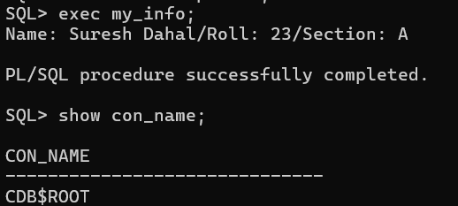
- Display information about the Container Database
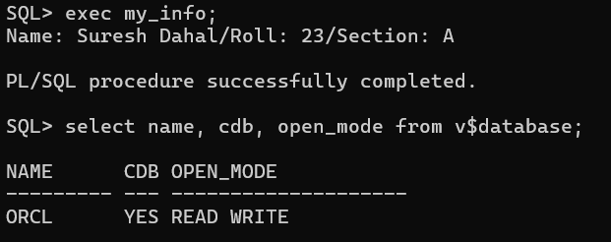
- Display all Pluggable Databases
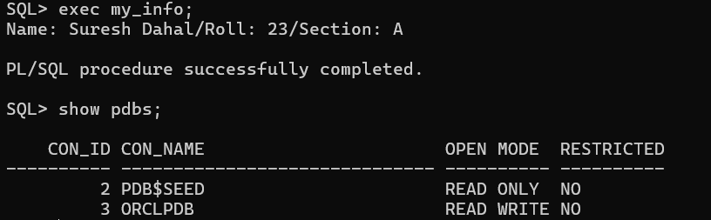
- Switch from the Root Container to a Pluggable Database
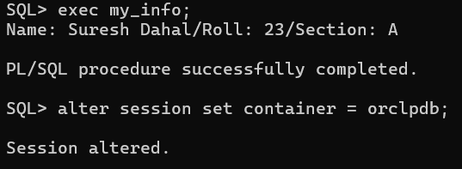
- Verify the current container
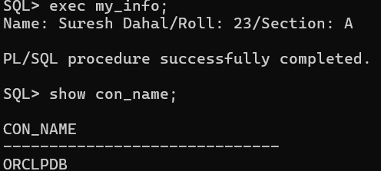
- Return to the Root Container
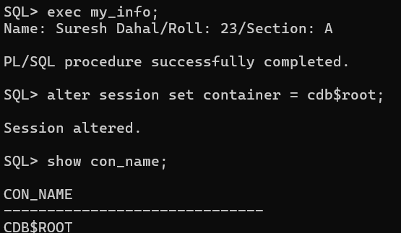
- View the open mode of all PDBs
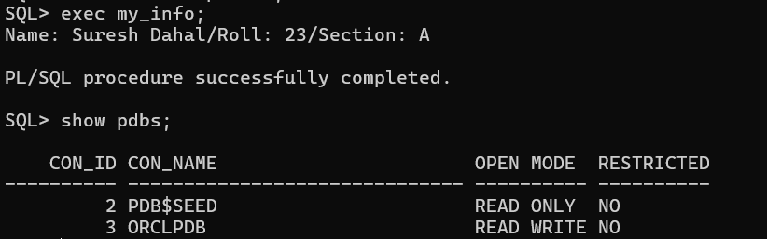

- Change the open mode of a PDB
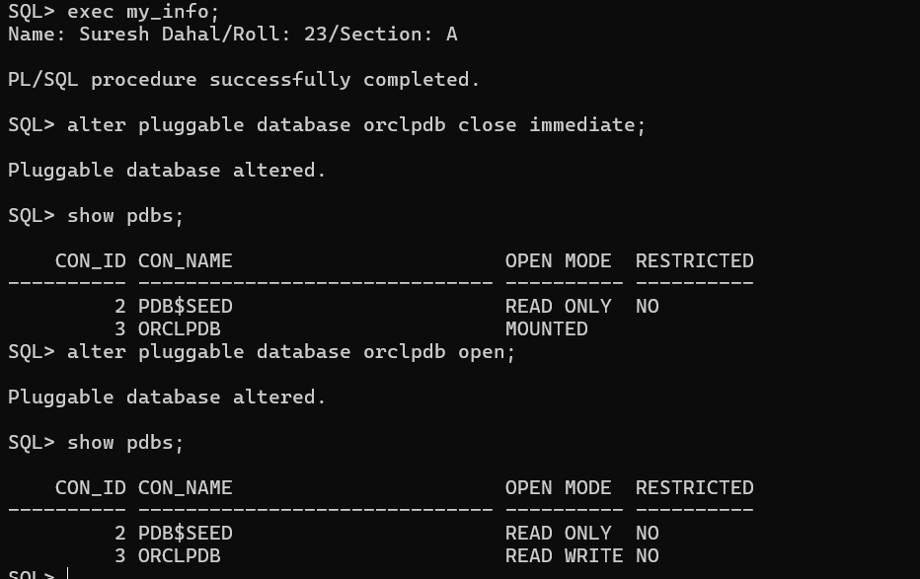
2. WORKING WITH STARTUP AND SHUTDOWN MODES IN ORACLE.
THEORY:
Oracle Database provides different startup and shutdown modes to control how the database is started and stopped. These modes are used for database administration, maintenance, recovery, and backup.
Startup Modes
- STARTUP NOMOUNT – Starts the Oracle instance by allocating memory and starting background processes. The control files are not opened.
- STARTUP MOUNT – Opens the control files but does not open the database. Used for recovery and maintenance operations.
- STARTUP OPEN (or simply STARTUP) – Opens the database for normal user access.
- STARTUP FORCE – Shuts down the currently running database (if necessary) and restarts it.
- ALTER SYSTEM SUSPEND – Suspends all database I/O operations temporarily.
- ALTER SYSTEM RESUME – Resumes normal database operations after suspension.
Shutdown Modes
- SHUTDOWN NORMAL – Waits for all users to disconnect before shutting down the database. No new connections are allowed.
- SHUTDOWN TRANSACTIONAL – Waits for active transactions to complete before shutting down.
- SHUTDOWN IMMEDIATE – Rolls back uncommitted transactions, disconnects users, and shuts down the database immediately.
- SHUTDOWN ABORT – Terminates the database immediately without waiting for users or transactions. Recovery is performed automatically during the next startup.

STEPS:
STARTUP MODES
1. Startup Database Normally
STARTUP;
2. Startup Database in NOMOUNT Mode
SHUTDOWN IMMEDIATE;
STARTUP NOMOUNT;
3. Startup Database in MOUNT Mode
SHUTDOWN IMMEDIATE;
STARTUP MOUNT;
4. Open the Database
ALTER DATABASE OPEN;
5. Startup Force
STARTUP FORCE;
6. Suspend Database
ALTER SYSTEM SUSPEND;
7. Resume Database
ALTER SYSTEM RESUME;

SHUTDOWN MODES
1. Shutdown Normal
SHUTDOWN NORMAL;
2. Shutdown Transactional
SHUTDOWN TRANSACTIONAL;
3. Shutdown Immediate
SHUTDOWN IMMEDIATE;
4. Shutdown Abort
SHUTDOWN ABORT;

OUTPUT:
STARTUP MODES:
  - Startup database normally
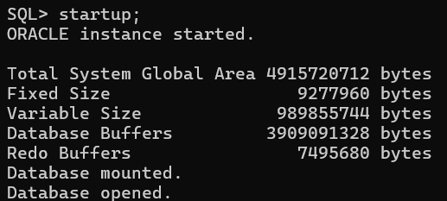
  - Startup database in NOMOUNT mode
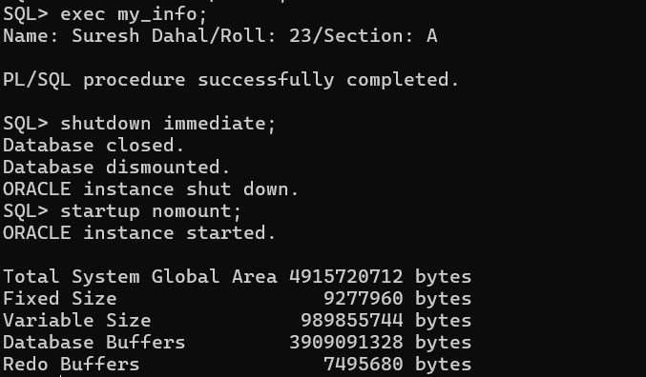
  - Startup database in MOUNT mode
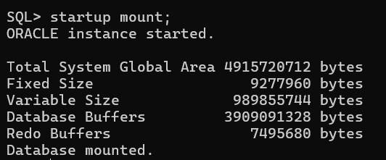

  - Open the database
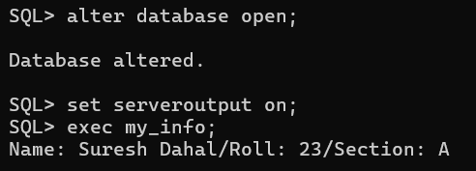
  - Startup force
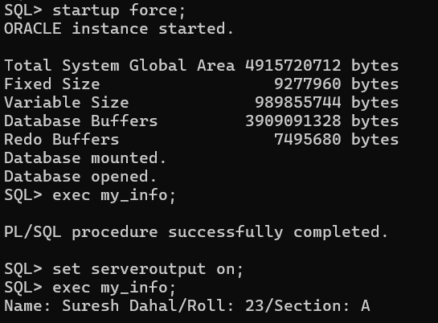
  - Suspend database
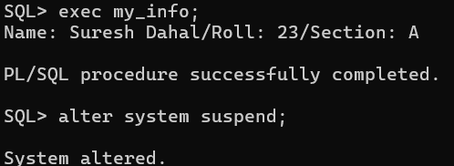
  - Resume database
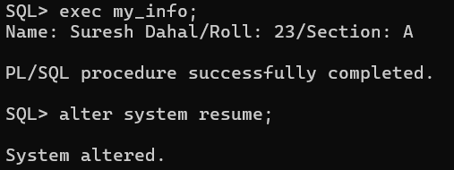
SHUTDOWN MODES:
- Shutdown normal
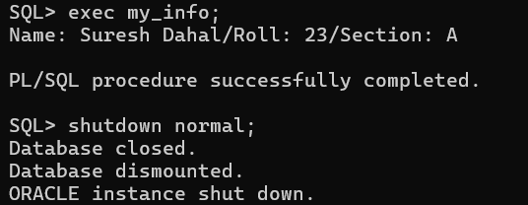
- Shutdown transactional
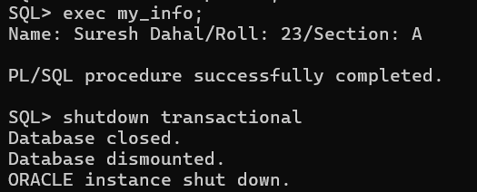
- Shutdown immediate
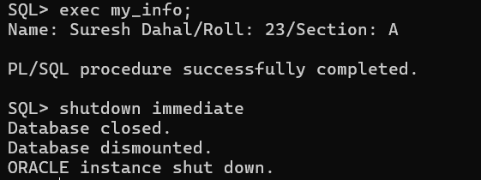
- Shutdown abort
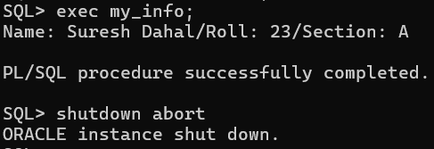
3. USING ORACLE NET CONFIGURATION ASSISTANT (NETCA) FOR NET SERVICE CONFIGURATION.
THEORY:
Oracle Net
Oracle Net is Oracle's networking technology that enables communication between Oracle clients and Oracle database servers over a network.
Oracle Listener
An Oracle Listener is a server-side process that listens for incoming client connection requests and establishes connections between Oracle clients and the database. By default, the listener uses the TCP protocol on port 1521.
TNS (Transparent Network Substrate)
TNS is Oracle's networking protocol that enables communication between Oracle clients and Oracle databases. It allows users to connect to a database using a service name instead of specifying the complete connection details.
Example:
CONNECT system/password@ORCLPDB
listener.ora
The listener.ora file stores the configuration of Oracle Listeners, including the listener name, protocol, host, port number, and database services. It is automatically updated by NetCA.
Default location:
ORACLE_HOME\network\admin
tnsnames.ora
The tnsnames.ora file stores Local Net Service Names that map a service alias to the database connection details such as host, port, and service name. Oracle clients use this file to connect to the database.
Default location:
ORACLE_HOME\network\admin
Oracle Net Configuration Assistant (NetCA)
Oracle Net Configuration Assistant (NetCA) is a graphical utility used to configure Oracle Net Services. It helps users create, modify, test, and delete listeners and Local Net Service Names without manually editing the network configuration files.

STEPS:
Part A: Listener Configuration
Step 1: Add a Listener
- Select Listener Configuration.
- Click Next.
- Select Add.
- Enter the Listener Name
- Select TCP protocol.
- Enter the Port Number (1521).
- Click Next.
- Finish the configuration.

Step 2: Test the Listener
- Open NetCA.
- Select Listener Configuration.
- Verify that the listener has been successfully created.
- Ensure the listener is active.

Step 3: Delete the Listener
- Select Listener Configuration.
- Select Delete.
- Choose the Listener (LISTENER).
- Click Next.
- Finish the deletion.

Part B: Local Net Service Name Configuration
Step 4: Add a Local Net Service Name
- Select Local Net Service Name Configuration.
- Click Add.
- Enter the Service Name (e.g., ORCLPDB).
- Select TCP as the protocol.
- Enter the Host Name (e.g., localhost).
- Enter the Listener Port (1521).
- Enter the Username and Password.
- Test the connection.
- Assign a Net Service Name.
- Finish the configuration.

Step 5: Test the Local Net Service Name
Use the Test option provided by NetCA.
OR
Verify using SQL*Plus.
CONNECT system/password@ORCLPDB;

Step 6: Delete the Local Net Service Name
- Select Local Net Service Name Configuration.
- Choose Delete.
- Select the configured Net Service Name.
- Finish the deletion.

Part C: Listener Control Commands
Step 7: Start the Listener
Open Command Prompt and execute:
lsnrctl start

Step 8: Check Listener Status
lsnrctl status

Step 9: Reload the Listener
lsnrctl reload

Step 10: Stop the Listener
lsnrctl stop

OUTPUT:
PART A: Listener Configuration
Step 1: Add a Listener
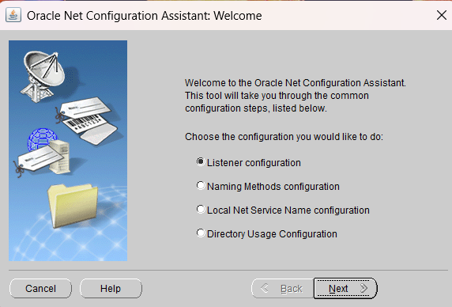
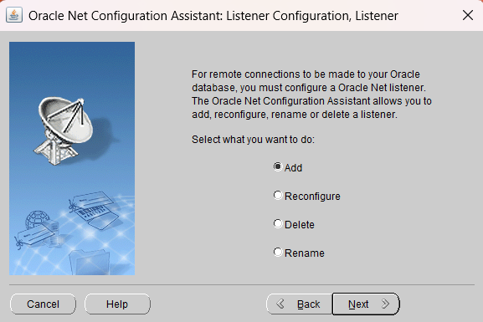
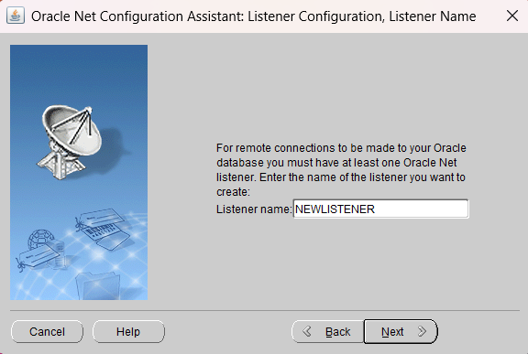
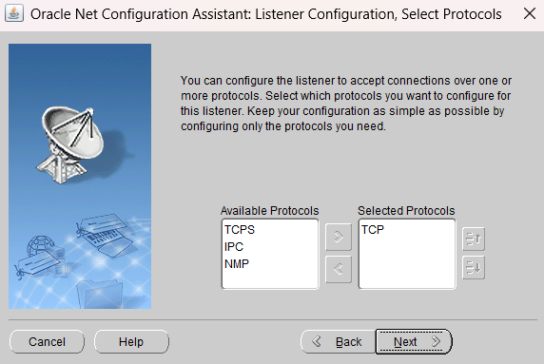
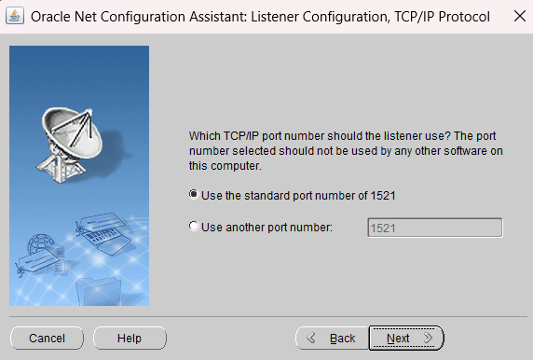
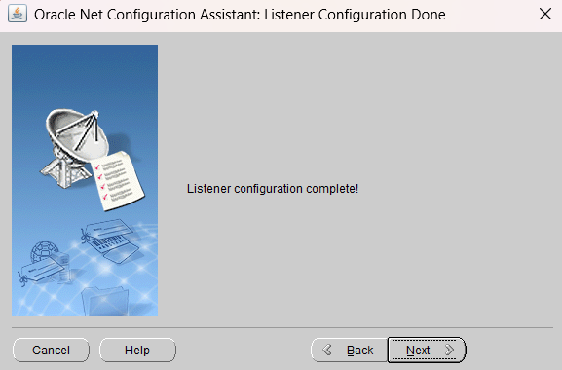
Step 2: Test the listener
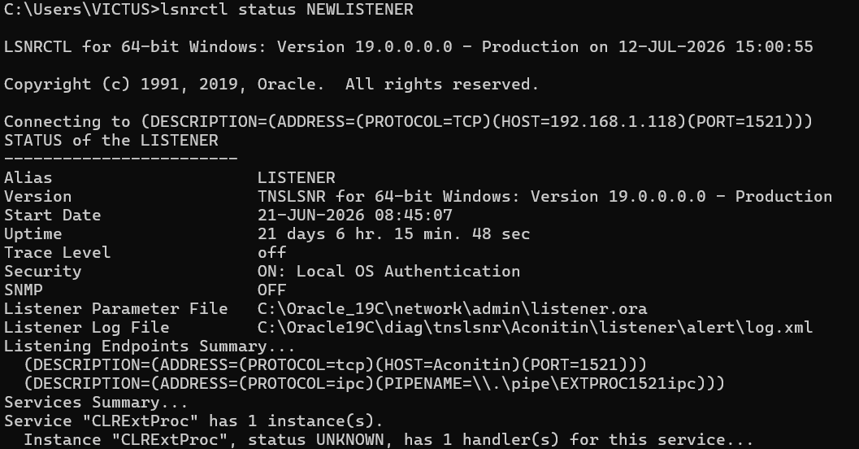
Step 3: Delete the listener
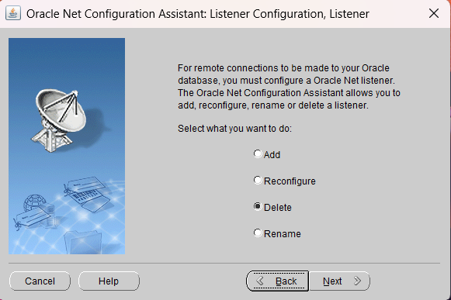
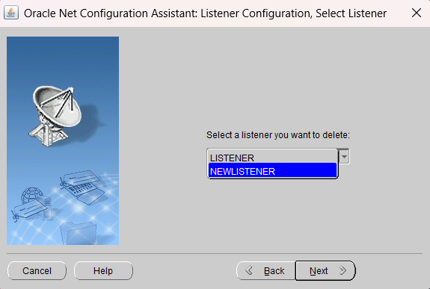
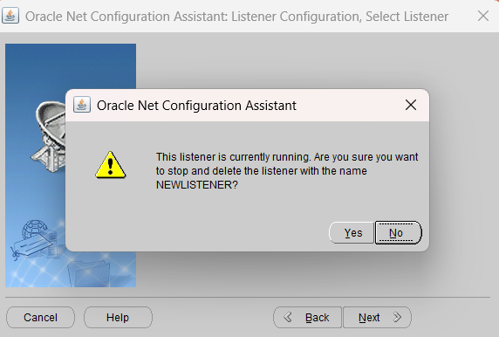
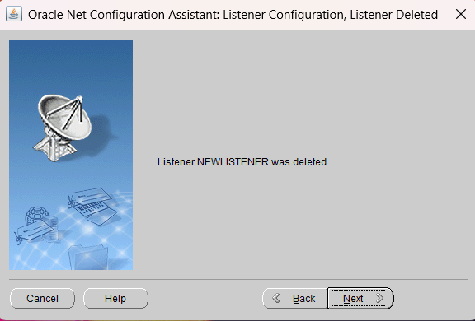
Verify whether the listener has been deleted
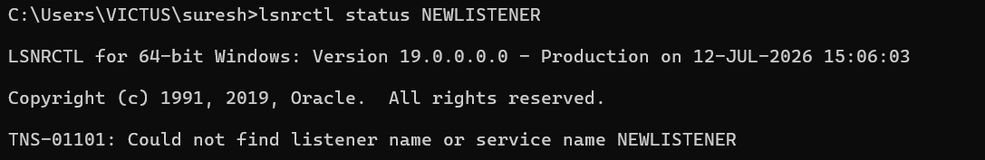
Part B: Local Net Service Name Configuration
Step 4: Add a Local Net Service Name
- Select Local Net Service Name Configuration.
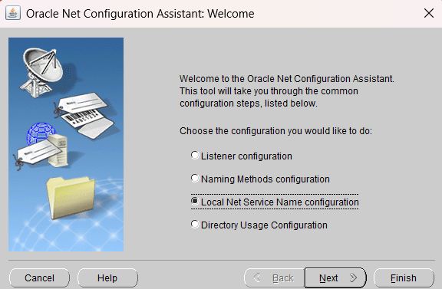
- Click Add.
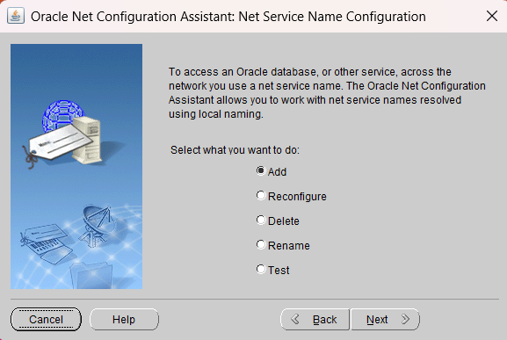
- Enter the Service Name (e.g., ORCLPDB).
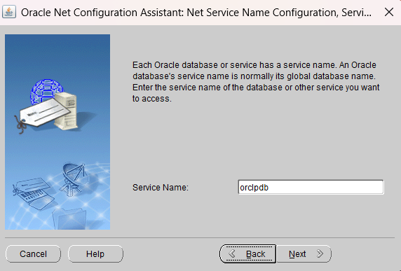
- Select TCP as the protocol.
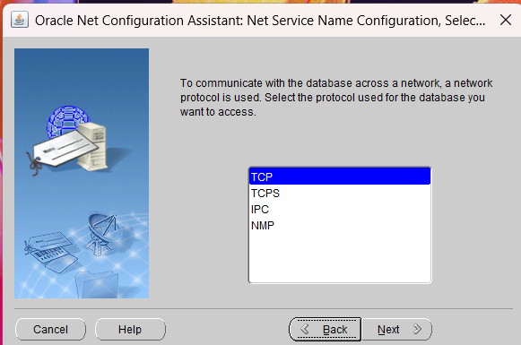
- Enter the Host Name (e.g., localhost).
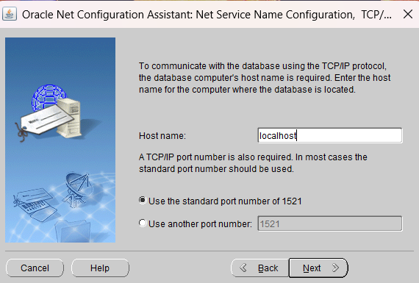
- Test the connection. 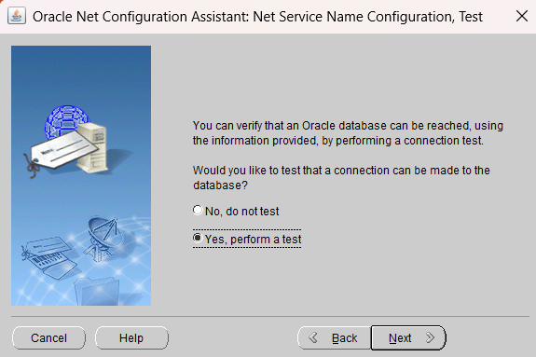
- Change login username and password
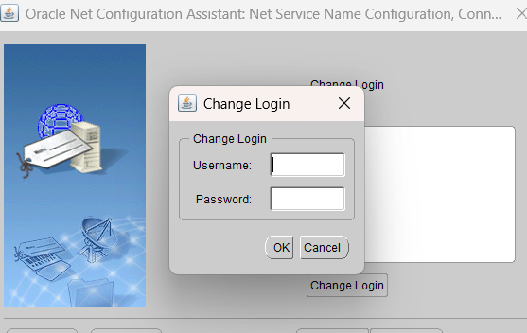
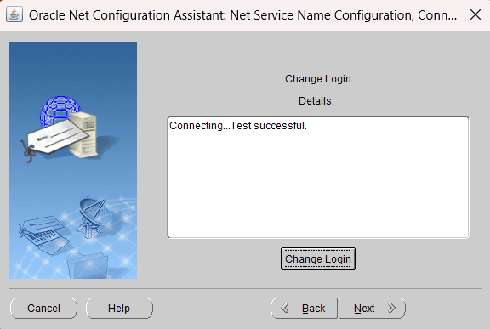
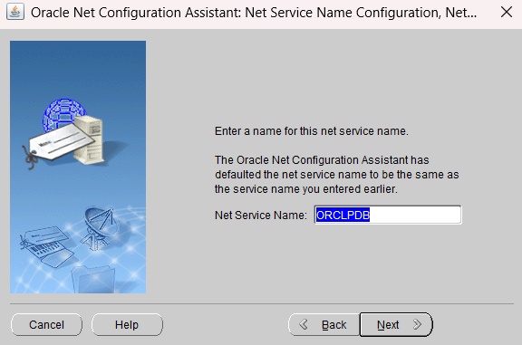
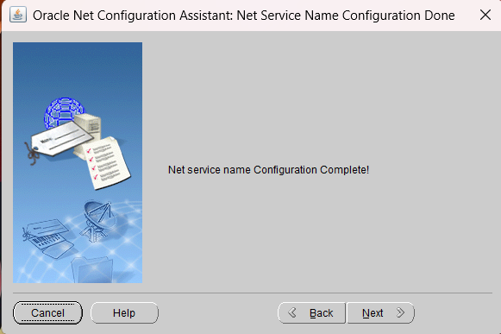
Step 5: Test the Local Net Service Name
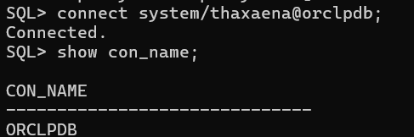
Step 6: Delete the Local Net Service Name
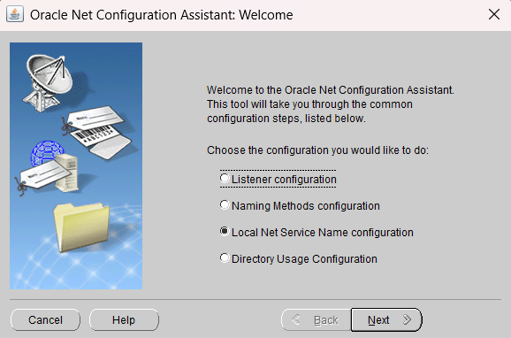
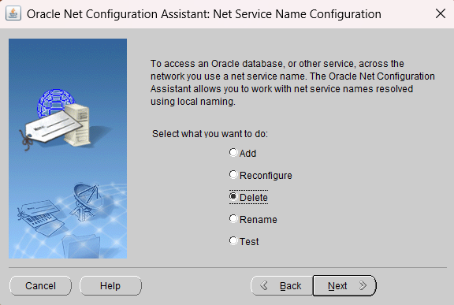
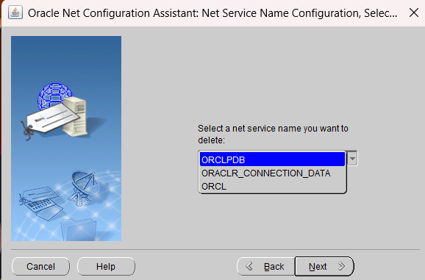
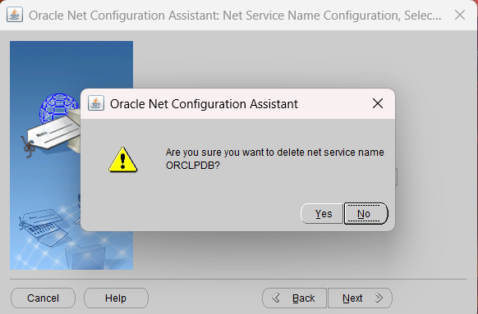
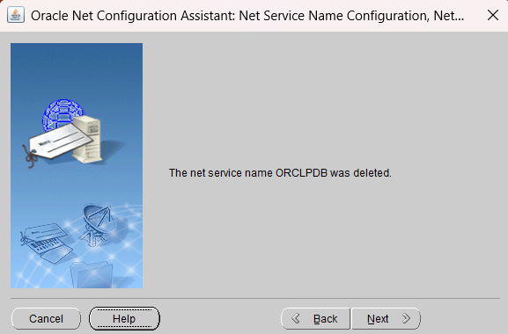
Verify delete
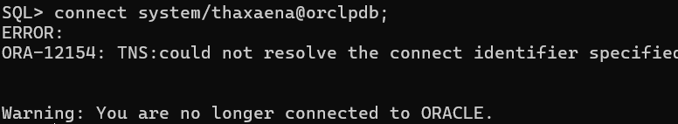
Part C: Listener Control Commands
Step 7: Start the Listener
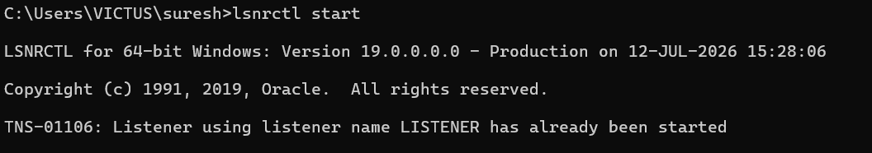
Step 8: Check Listener Status
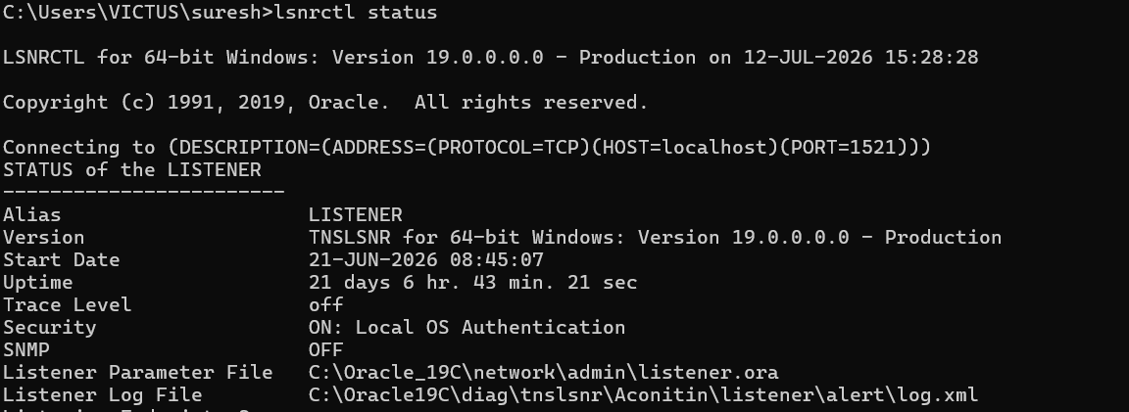
Step 9: Reload the Listener
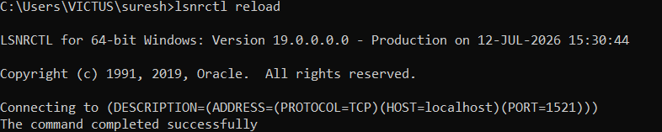
Step 10: Stop the Listener
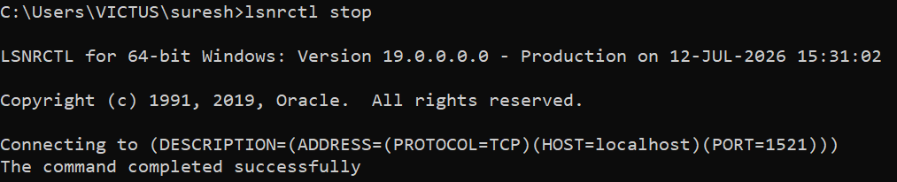

4. UNLOCKING HR-SCHEMA IN ORACLE 19C AND CONNECTING WITH HR USER.
THEORY:
HR Schema
The HR (Human Resources) Schema is Oracle's sample database schema used for learning and practicing SQL, PL/SQL, and database administration. It contains tables related to employees, departments, jobs, locations, countries, regions, and job history.
By default, the HR account is locked after Oracle installation for security reasons. It must be unlocked before it can be used
TNS (Transparent Network Substrate) Service
A TNS Service is a local network service name that allows Oracle clients to connect to a database using an easy-to-remember alias instead of specifying the complete connection details. It is configured using Oracle Net Configuration Assistant (NetCA) or manually through the tnsnames.ora file.
Example:
CONNECT hr/password@ORCLPDB;
Pluggable Database (PDB)
Oracle 19c uses Multitenant Architecture, where a Container Database (CDB) contains one or more Pluggable Databases (PDBs). Since the HR schema resides inside a PDB, the session must be switched to the appropriate PDB before unlocking the HR account.
ALTER USER Statement
The ALTER USER statement is used to modify the properties of an existing user account, such as changing the password, locking or unlocking the account, and assigning roles or privileges.
Syntax:
ALTER USER username IDENTIFIED BY password ACCOUNT UNLOCK;

STEPS:
Step 1: Create a TNS Service
Using Oracle Net Configuration Assistant (NetCA):
- Open NetCA.
- Select Local Net Service Name Configuration.
- Click Add.
- Enter the Service Name (e.g., ORCLPDB).
- Select TCP as the protocol.
- Enter the Host Name (e.g., localhost).
- Enter the Listener Port (1521).
- Test the connection.
- Assign the Net Service Name.
- Finish the configuration.

Step 3: Connect as SYSDBA
SQLPlus / AS SYSDBA;

Step 4: Verify the Current Container
SHOW CON_NAME;

Step 5: Switch to the ORCLPDB Container
ALTER SESSION SET CONTAINER = ORCLPDB;

Step 6: Verify the Current Container
SHOW CON_NAME;

Step 7: Unlock the HR Account
Replace your_password with your own password.
ALTER USER hr IDENTIFIED BY your_password ACCOUNT UNLOCK;

Step 8: Disconnect from SYS User
DISCONNECT;

Step 9: Connect Using the HR User
CONNECT hr/password@ORCLPDB;

Step 10: Verify the Connected User
SHOW USER;

Step 11: Verify the Current Container
SHOW CON_NAME;

OUTPUT:
Step 1: Configure listener
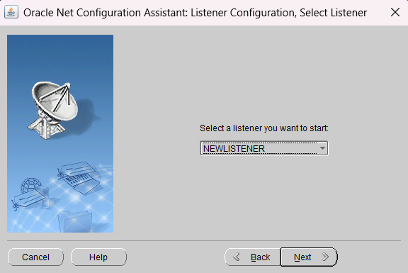
Test the connection

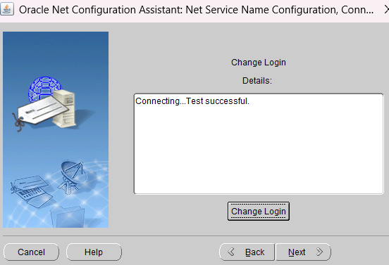

Step 3: Connect as SYSDBA
Step 4: Verify the Current Container
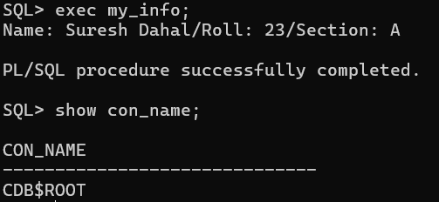
Step 5: Switch to the ORCLPDB Container and verify the connection name
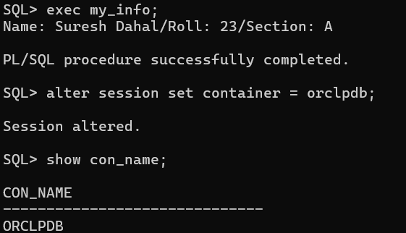

Step 7: Unlock the HR Account
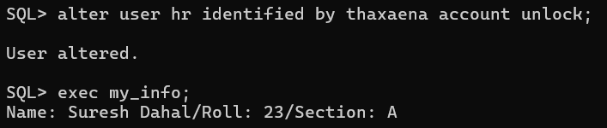
Step 8: Disconnect from SYS User
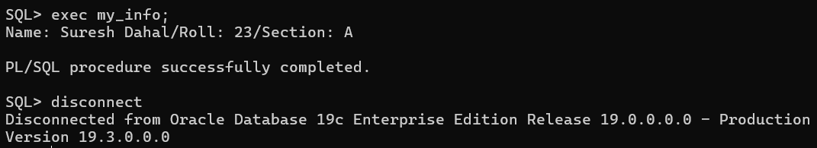
Step 9: Connect Using the HR User
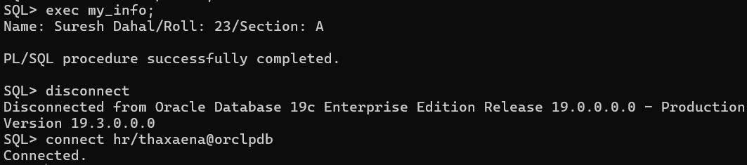
Step 10: Verify the Connected User
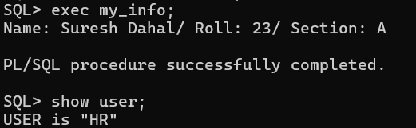
Step 11: Verify the Current Container
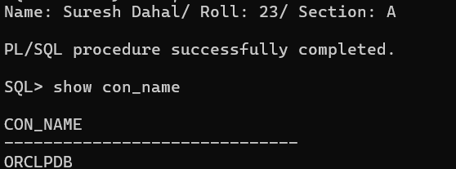

- DISPLAYING BASIC INFORMATION IN ORACLE DATABASE AND FORMATTING OUTPUT IN SQL PLUS.
THEORY:
Oracle provides various data dictionary views to retrieve information about database users, privileges, and tablespaces. These views help database administrators monitor and manage user accounts.
SQL*Plus also provides formatting commands that improve the readability of query results by adjusting line size, formatting column display, and limiting the number of rows displayed.
USER Information
Oracle stores information about user accounts such as username, account status, and default tablespace in the DBA_USERS data dictionary view.
Current User
The currently connected user can be displayed using the SHOW USER command or the USER function.
User Privileges
Privileges determine the actions a user can perform in the database. System privileges granted to users can be viewed using the DBA_SYS_PRIVS view.
Database Users
Information about all users present in the database can be viewed using the DBA_USERS view.
SQL*Plus Formatting
SQL*Plus provides formatting commands such as SET LINESIZE, COLUMN, and row limiting using FETCH FIRST or ROWNUM to improve the presentation of query results.

STEPS:
Steps and Commands
Step 1: View Username, Account Status, and Default Tablespace
SELECT USERNAME,
ACCOUNT_STATUS,
DEFAULT_TABLESPACE
FROM DBA_USERS;

Step 2: Display the Current User
SHOW USER;
Step 3: Display Privileges Granted to a User
Replace HR with the desired username if needed.
SELECT GRANTEE,
PRIVILEGE
FROM DBA_SYS_PRIVS
WHERE GRANTEE = 'HR';

Step 4: Display All Users in the Database
SELECT USERNAME
FROM DBA_USERS;

Formatting Output in SQL*Plus
Step 5: Set Line Size
SET LINESIZE 120;

Step 6: Format Column Display
COLUMN USERNAME FORMAT A20;
COLUMN ACCOUNT_STATUS FORMAT A20;
COLUMN DEFAULT_TABLESPACE FORMAT A20;

Step 7: Display Formatted Output
SELECT USERNAME,
ACCOUNT_STATUS,
DEFAULT_TABLESPACE
FROM DBA_USERS;

Step 8: Limit the Number of Results
Using Oracle 12c/19c row limiting clause:
SELECT USERNAME,
ACCOUNT_STATUS
FROM DBA_USERS
FETCH FIRST 5 ROWS ONLY;
or using ROWNUM:
SELECT USERNAME,
ACCOUNT_STATUS
FROM DBA_USERS
WHERE ROWNUM <= 5;
OUTPUT:
Step 1: View Username, Account Status, and Default Tablespace
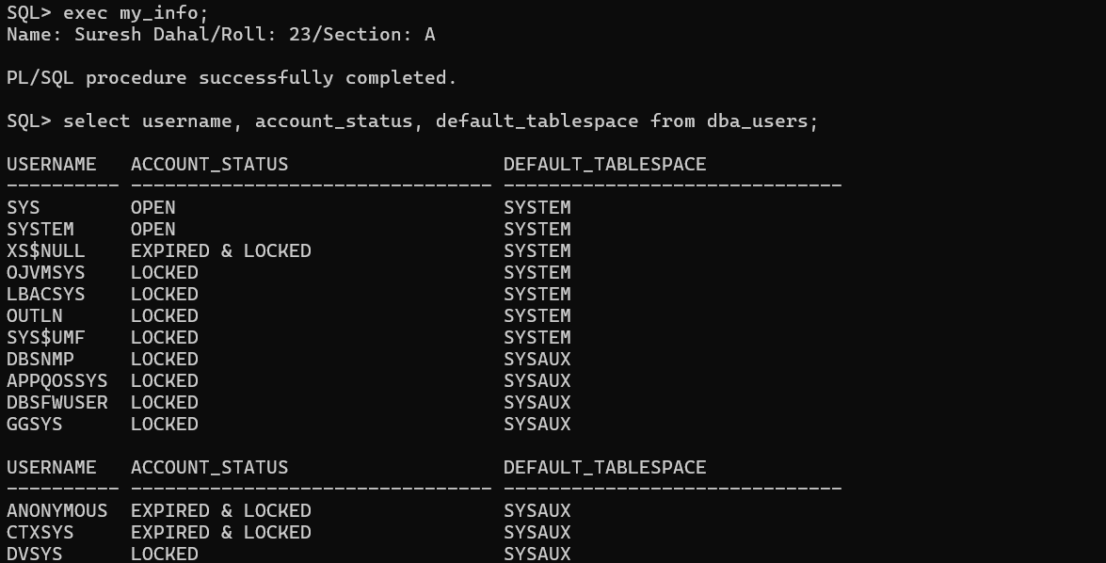
Step 2: Display the Current User
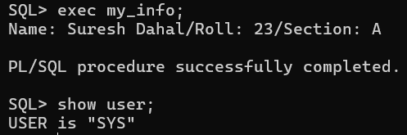
Step 3: Display Privileges Granted to a User
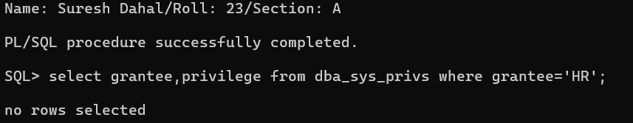
Step 4: Display All Users in the Database
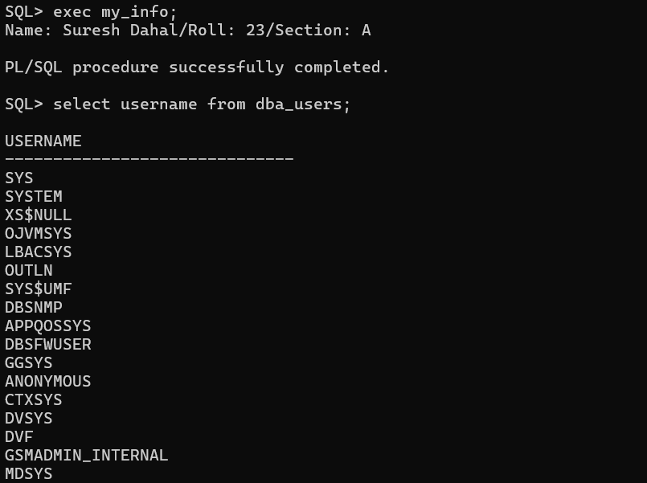
Formatting Output in SQL*Plus
Step 5: Set Line Size
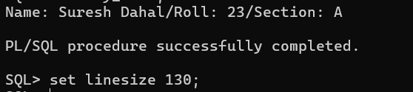
Step 6: Format Column Display
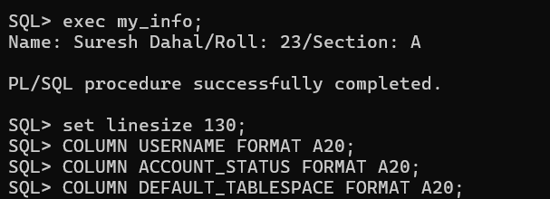
Step 7: Display Formatted Output
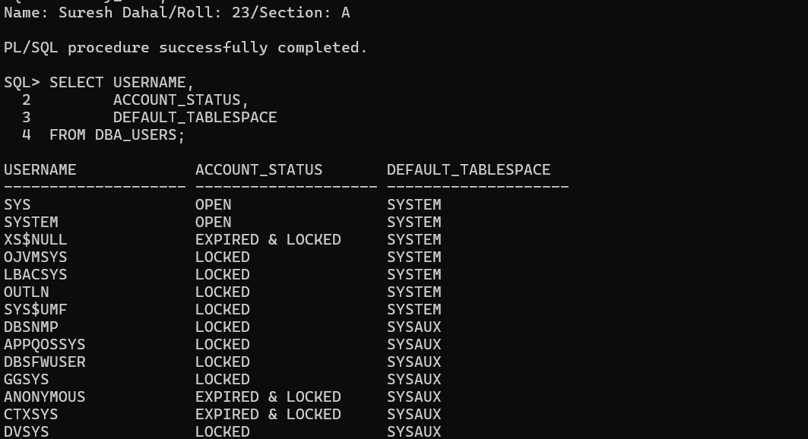
Step 8: Limit the Number of Results
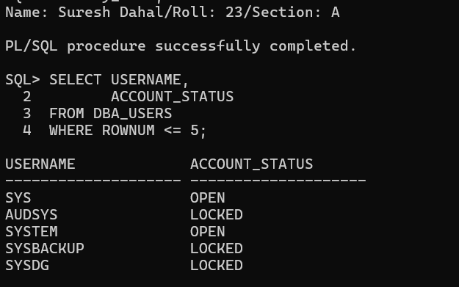

- WORKING WITH TABLESPACE AND DATA FILE
THEORY:
Tablespace
A tablespace is a logical storage unit in an Oracle database that stores database objects such as tables, indexes, and views. Each tablespace consists of one or more physical data files stored on disk.
Oracle mainly uses three types of tablespaces:
- Permanent Tablespace – Stores permanent database objects such as tables and indexes.
- Temporary Tablespace – Stores temporary data generated during sorting and query processing.
- Undo Tablespace – Stores undo information used for transaction rollback and recovery.

DBA_TABLESPACES View
DBA_TABLESPACES is a data dictionary view that displays information about all tablespaces in the database. It is accessible only to users with DBA privileges.

USER_TABLESPACES View
USER_TABLESPACES displays information about the tablespaces accessible to the currently connected user.

V$TABLESPACE View
V$TABLESPACE is a dynamic performance view that provides real-time information about the current state of tablespaces in the database.

DBA_DATA_FILES View
DBA_DATA_FILES displays detailed information about all data files belonging to permanent tablespaces, including their names, sizes, and associated tablespaces.

V$DATAFILE View
V$DATAFILE is a dynamic performance view that provides real-time information about data files currently being used by the Oracle database.

STEPS:
(a) Displaying Tablespaces
Step 1: Display All Tablespaces Using DBA_TABLESPACES
SELECT TABLESPACE_NAME,
STATUS,
CONTENTS
FROM DBA_TABLESPACES;

Step 2: Login as HR User
CONNECT hr/password@ORCLPDB;

Step 3: Display Tablespace Associated with Current User
SELECT TABLESPACE_NAME,
STATUS
FROM USER_TABLESPACES;

Step 4: Connect Back as SYSDBA
CONNECT / AS SYSDBA;

Step 5: Display Real-Time Information Using V$TABLESPACE
SELECT TS#,
NAME
FROM V$TABLESPACE;

Step 6: Display Tablespaces with Their Types
SELECT TABLESPACE_NAME,
CONTENTS
FROM DBA_TABLESPACES;

(b) Create a Permanent Tablespace and Display the Newly Created Tablespace
Step 7: Connect as SYSDBA
CONNECT / AS SYSDBA;

Step 8: Verify the Current Container
SHOW CON_NAME;
If the current container is not ORCLPDB, switch to it:
ALTER SESSION SET CONTAINER = ORCLPDB;

Step 9: Create a Permanent Tablespace
Using your Oracle installation path:
CREATE TABLESPACE suresh_tbs1_23
DATAFILE 'C:\Oracle19C\oradata\ORCL\orclpdb\suresh_df1_23.dbf'
SIZE 20M
AUTOEXTEND ON
NEXT 5M
MAXSIZE 100M;

Step 10: Display the Newly Created Tablespace
SELECT TABLESPACE_NAME,
STATUS,
CONTENTS
FROM DBA_TABLESPACES
WHERE TABLESPACE_NAME = 'SURESH_TBS1_23';

Step 11: Display the List of Tablespaces
SELECT TABLESPACE_NAME,
CONTENTS
FROM DBA_TABLESPACES
ORDER BY TABLESPACE_NAME;

(c) Modify the Tablespace Created Above
Step 12: Change the Tablespace Status to OFFLINE
ALTER TABLESPACE suresh_tbs1_23 OFFLINE;

Step 13: Verify the Tablespace Status
SELECT TABLESPACE_NAME,
STATUS
FROM DBA_TABLESPACES
WHERE TABLESPACE_NAME = 'SURESH_TBS1_23';

Step 14: Change the Tablespace Status to ONLINE
ALTER TABLESPACE suresh_tbs1_23 ONLINE;

Step 15: Verify the Tablespace Status Again
SELECT TABLESPACE_NAME,
STATUS
FROM DBA_TABLESPACES
WHERE TABLESPACE_NAME = 'SURESH_TBS1_23';

Step 1: 6Add a New Data File to the Tablespace
ALTER TABLESPACE suresh_tbs1_23
ADD DATAFILE 'C:\Oracle19C\oradata\ORCL\orclpdb\suresh_df2_23.dbf'
SIZE 20M
AUTOEXTEND ON
NEXT 5M
MAXSIZE 100M;

Step 17: Verify the Data Files
SELECT TABLESPACE_NAME,
FILE_NAME
FROM DBA_DATA_FILES
WHERE TABLESPACE_NAME = 'SURESH_TBS1_23';

Step 18: Rename the Tablespace
ALTER TABLESPACE suresh_tbs1_23
RENAME TO suresh_dahal_tbs1_23;

Step 19: Verify the Renamed Tablespace
SELECT TABLESPACE_NAME
FROM DBA_TABLESPACES
WHERE TABLESPACE_NAME = 'SURESH_DAHAL_TBS1_23';

(d) Create and Delete a Tablespace

Step 20: Create a New Tablespace
CREATE TABLESPACE test_tbs_by_suresh
DATAFILE 'C:\Oracle19C\oradata\ORCL\orclpdb\test_df_by_suresh.dbf'
SIZE 20M
AUTOEXTEND ON
NEXT 5M
MAXSIZE 100M;

Step 21: Display the Newly Created Tablespace
SELECT TABLESPACE_NAME,
STATUS,
CONTENTS
FROM DBA_TABLESPACES
WHERE TABLESPACE_NAME = 'TEST_TBS_BY_SURESH';

Step 22: Display the List of Tablespaces
SELECT TABLESPACE_NAME
FROM DBA_TABLESPACES
ORDER BY TABLESPACE_NAME;

Step 23: Delete the Tablespace
DROP TABLESPACE test_tbs_by_suresh
INCLUDING CONTENTS
AND DATAFILES;

Step 24: Display the List of Tablespaces Again
SELECT TABLESPACE_NAME
FROM DBA_TABLESPACES
ORDER BY TABLESPACE_NAME;

e) Displaying Data Files

Step 25: Display Information About Data Files Using DBA_DATA_FILES
SELECT FILE_NAME,
TABLESPACE_NAME,
BYTES,
AUTOEXTENSIBLE,
STATUS
FROM DBA_DATA_FILES;
This displays information about all data files in the database.

Step 26: Display Information About Data Files Using V$DATAFILE
SELECT FILE#,
NAME,
STATUS
FROM V$DATAFILE;
This displays real-time information about the data files currently being used by the database.

f) Resize the Data File Created in (b)

Step 27: Resize the Data File
ALTER DATABASE
DATAFILE 'C:\Oracle19C\oradata\ORCL\orclpdb\suresh_df1_23.dbf'
RESIZE 50M;
Step 28: Verify the Resized Data File
SELECT FILE_NAME,
BYTES/1024/1024 AS SIZE_MB
FROM DBA_DATA_FILES
WHERE FILE_NAME LIKE '%SURESH_DF1_23.DBF';

OUTPUT:
(a) Displaying Tablespaces
Step 1: Display All Tablespaces Using DBA_TABLESPACES
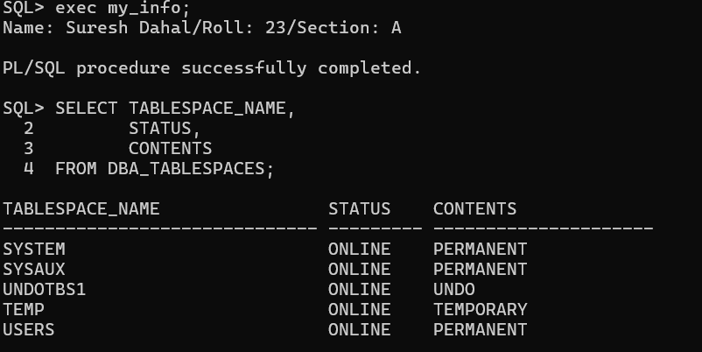
Step 2: Login as HR User
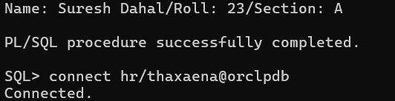
Step 3: Display Tablespace Associated with Current User
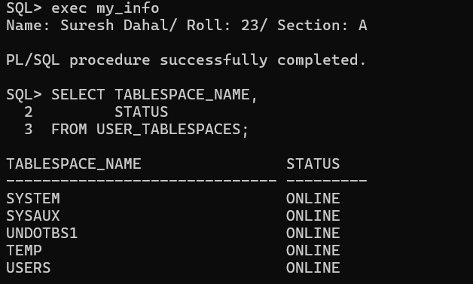
Step 4: Connect Back as SYSDBA
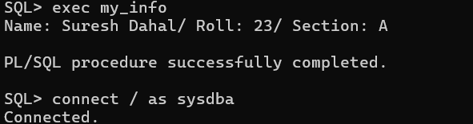

Step 5: Display Real-Time Information Using V$TABLESPACE
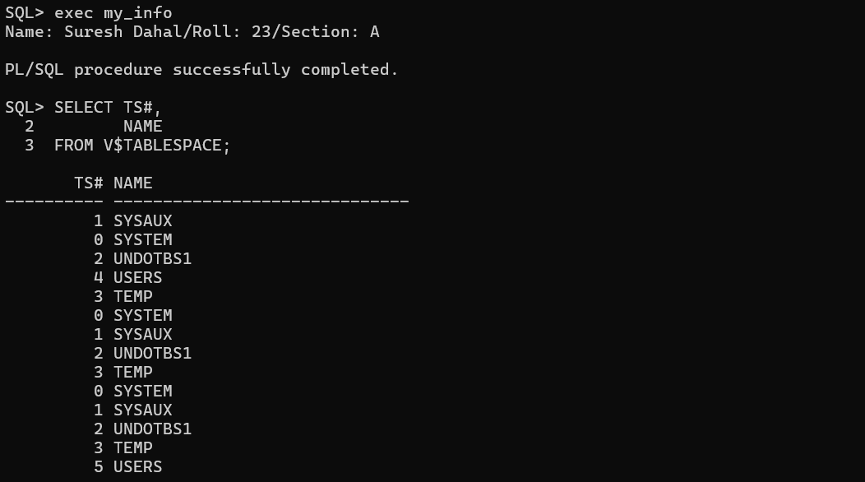
Step 6: Display Tablespaces with Their Types
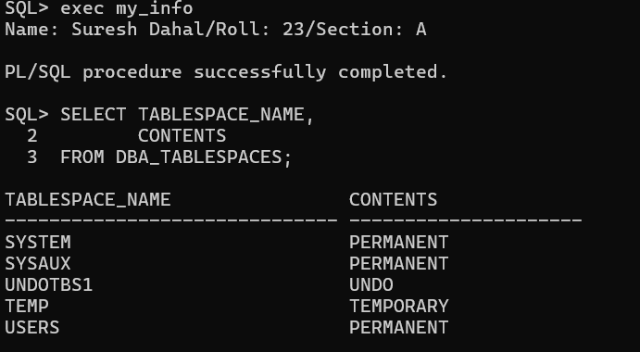
(b) Create a Permanent Tablespace and Display the Newly Created Tablespace
Step 7: Connect as SYSDBA
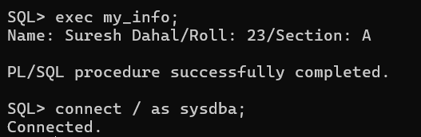
Step 8: Verify the Current Container
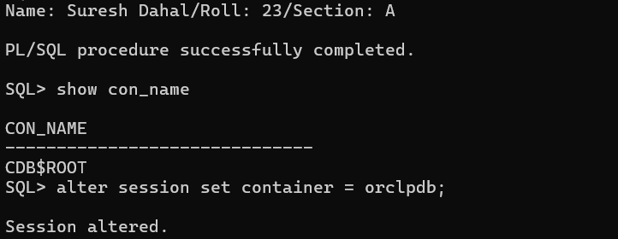
Step 9: Create a Permanent Tablespace
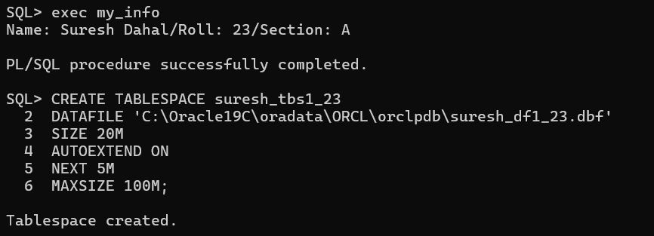
Step 10: Display the Newly Created Tablespace
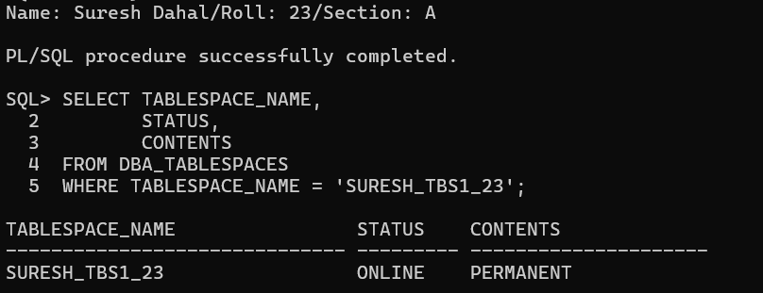
Step 11: Display the List of Tablespaces
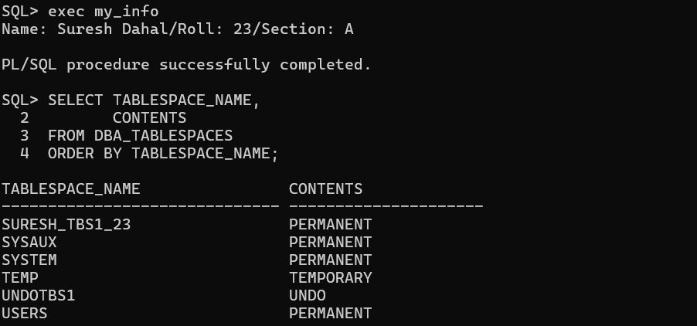
(c) Modify the Tablespace Created Above
Step 12: Change the Tablespace Status to OFFLINE
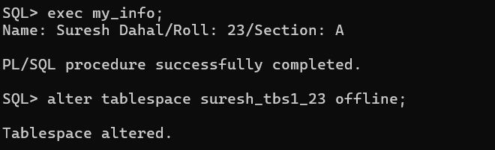
Step 13: Verify the Tablespace Status
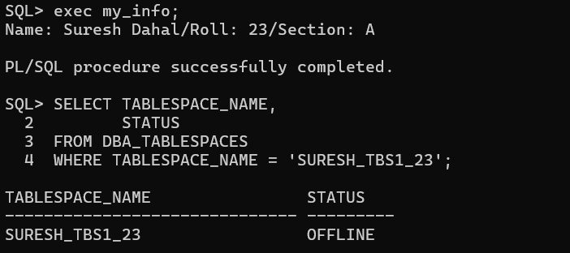
Step 14: Change the Tablespace Status to ONLINE
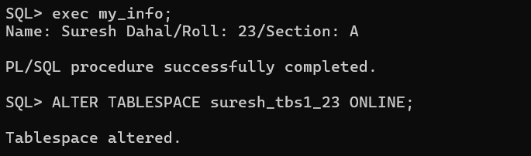
Step 15: Verify the Tablespace Status Again
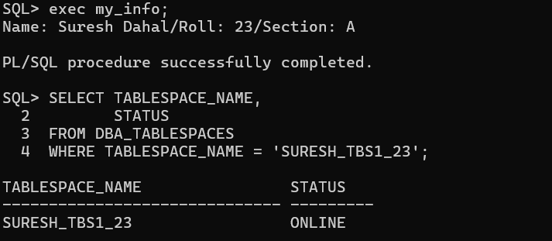
Step 16: Add a New Data File to the Tablespace
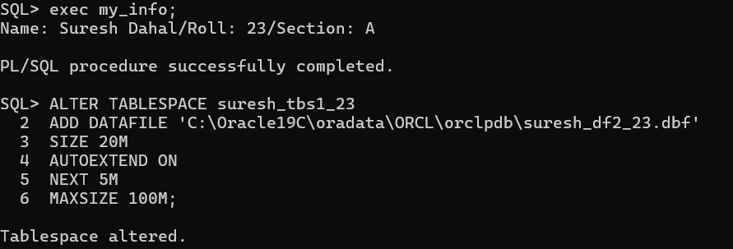

Step 17: Verify the Data Files
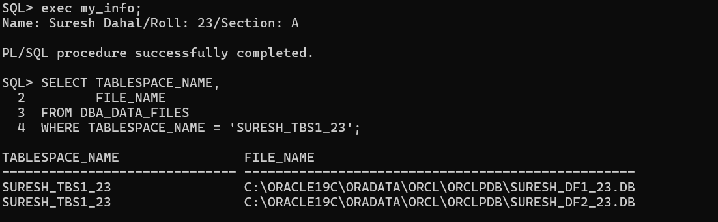
Step 18: Rename the Tablespace
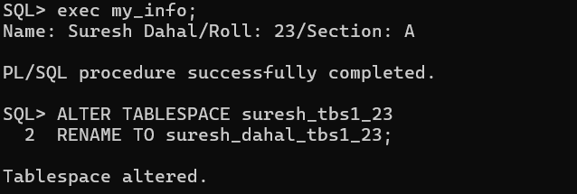
Step 19: Verify the Renamed Tablespace
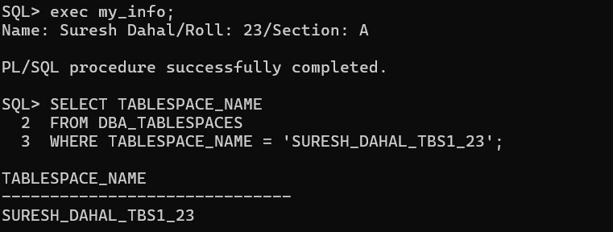
(d) Create and Delete a Tablespace
Step 20: Create a New Tablespace
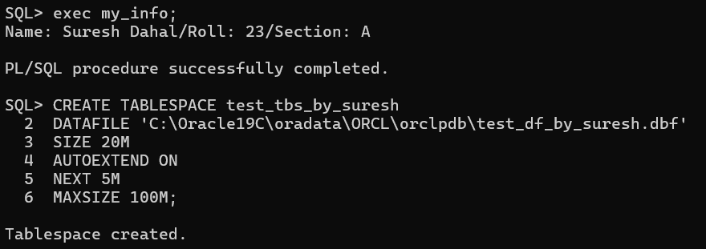
Step 21: Display the Newly Created Tablespace
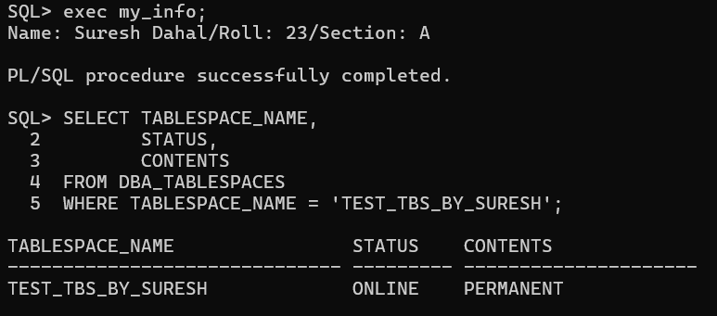
Step 22: Display the List of Tablespaces
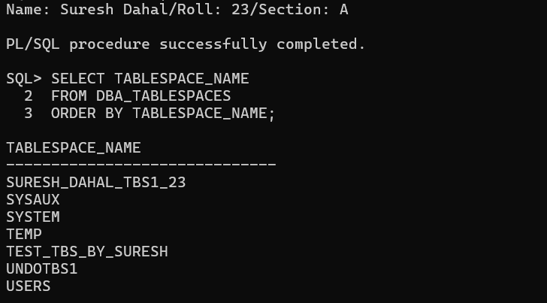
Step 23: Delete the Tablespace
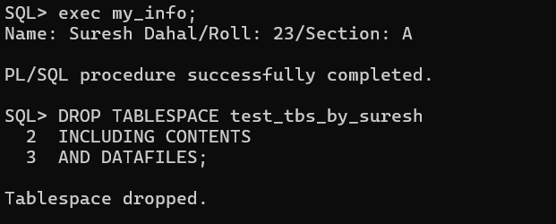

Step 24: Display the List of Tablespaces Again
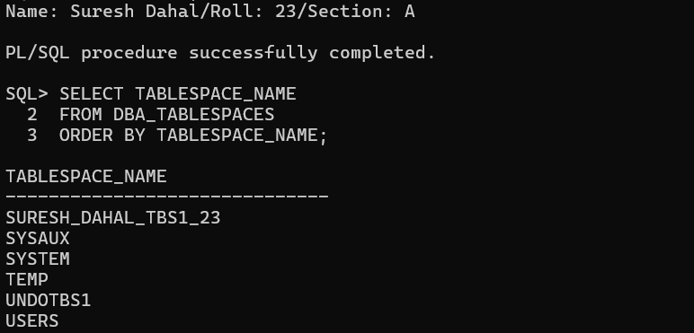
e) Displaying Data Files
Step 25: Display Information About Data Files Using DBA_DATA_FILES
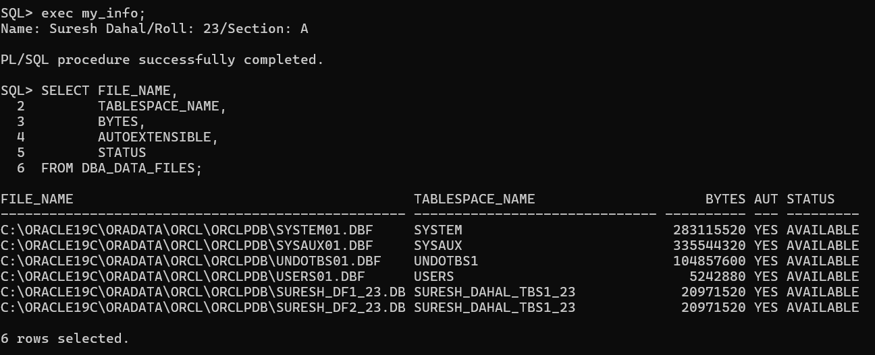
Step 26: Display Information About Data Files Using V$DATAFILE
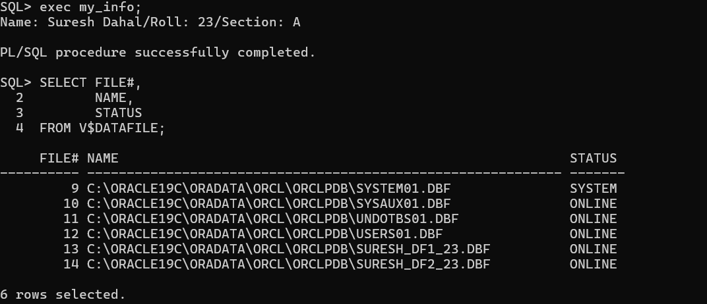
f) Resize the Data File Created in (b)

Step 27: Resize the Data File
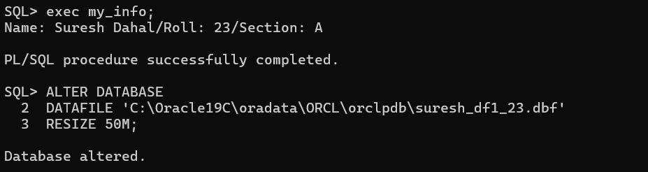Step 28: Verify the Resized Data File
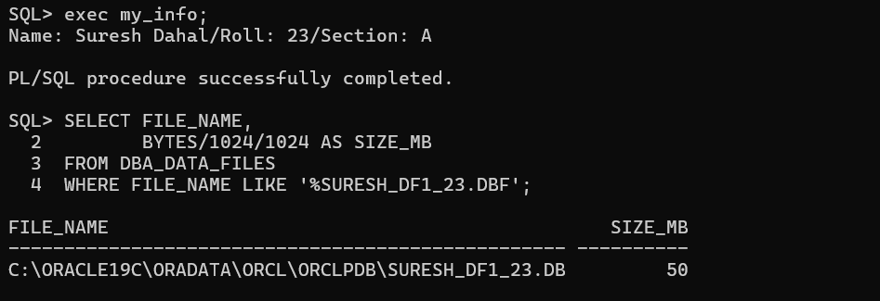

- WORKING WITH ORACLE SQL DEVELOPER
THEORY:
Oracle SQL Developer
Oracle SQL Developer is a free graphical database development tool provided by Oracle for working with Oracle databases. It enables users to create database connections, execute SQL and PL/SQL statements, manage database objects, browse schemas, and perform database administration tasks through an easy-to-use graphical interface.
Some features of Oracle SQL Developer include:
- Creating and managing database connections.
- Executing SQL and PL/SQL statements using SQL Worksheet.
- Browsing database objects such as tables, views, indexes, and procedures.
- Importing and exporting database data.
- Managing users and database administration tasks.
- Generating reports and viewing query results.

STEPS:
Step 1: Install Oracle SQL Developer
- Download Oracle SQL Developer.
- Install the software.
- Launch Oracle SQL Developer.

Part A: Create a Connection for SYSTEM User
Step 2: Create a New Database Connection
- Click New Connection (+).
- Enter the following details:
Field | Value
Connection Name | SYSTEM
Username | system
Password | Pass123
Connection Type | Basic
Hostname | localhost
Port | 1521
Service Name | ORCLPDB
- Click Test.
- Ensure the status shows Success.
- Click Connect.

Step 3: Execute Commands from SQL Worksheet
SHOW USER;
SHOW CON_NAME;
SELECT TABLESPACE_NAME
FROM DBA_TABLESPACES;

Part B: Create a Connection for HR User
Step 4: Create a New Database Connection
- Click New Connection (+).
- Enter the following details:
Field | Value
Connection Name | HR
Username | hr
Password | Your HR Password
Connection Type | Basic
Hostname | localhost
Port | 1521
Service Name | ORCLPDB (or your PDB name)
- Click Test.
- Ensure the status shows Success.
- Click Connect.

Step 5: Execute Commands from SQL Worksheet
SHOW USER;
SHOW CON_NAME;
SELECT EMPLOYEE_ID,
FIRST_NAME,
LAST_NAME
FROM EMPLOYEES;

Step 6: Execute Any Additional Query
SELECT DEPARTMENT_ID,
DEPARTMENT_NAME
FROM DEPARTMENTS;

OUTPUT:
Step 1: Install Oracle SQL Developer
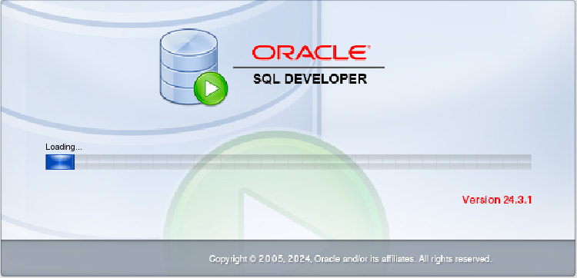
Part A: Create a Connection for SYSTEM User
Step 2: Create a New Database Connection
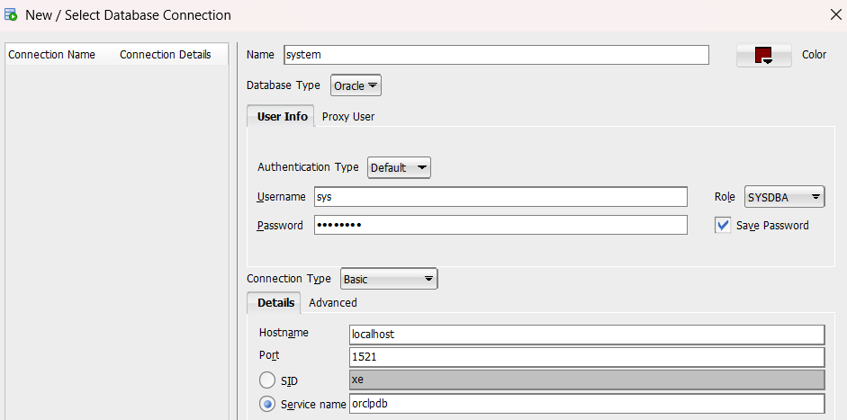

Step 3: Execute Commands from SQL Worksheet
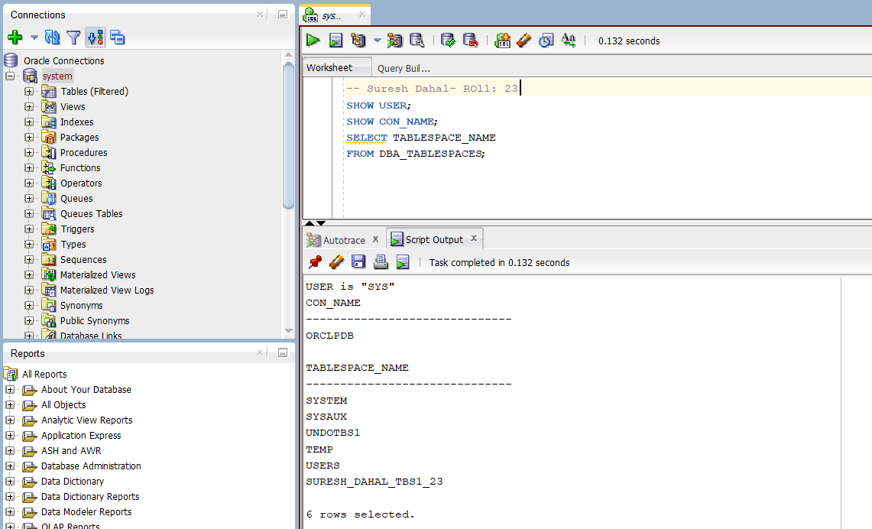
Part B: Create a Connection for HR User
Step 4: Create a New Database Connection
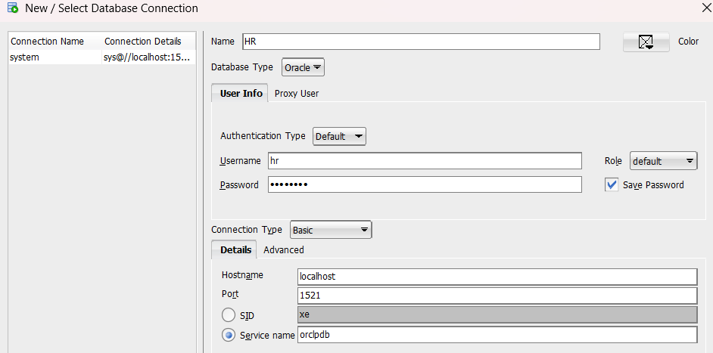

Step 5: Execute Commands from SQL Worksheet
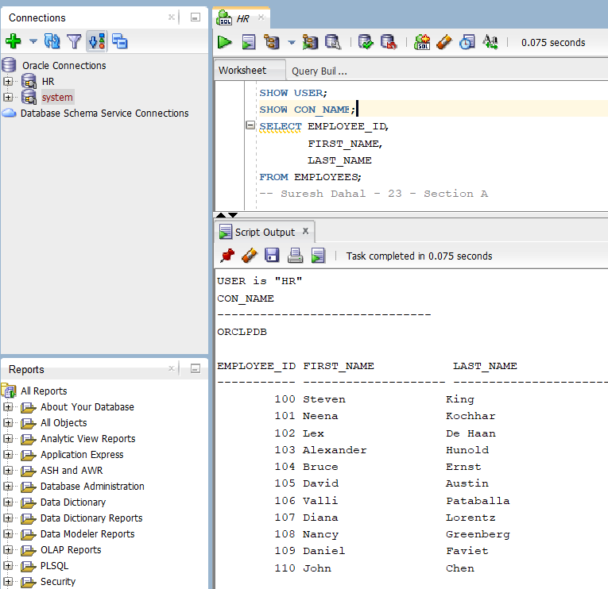

Step 6: Execute Any Additional Query

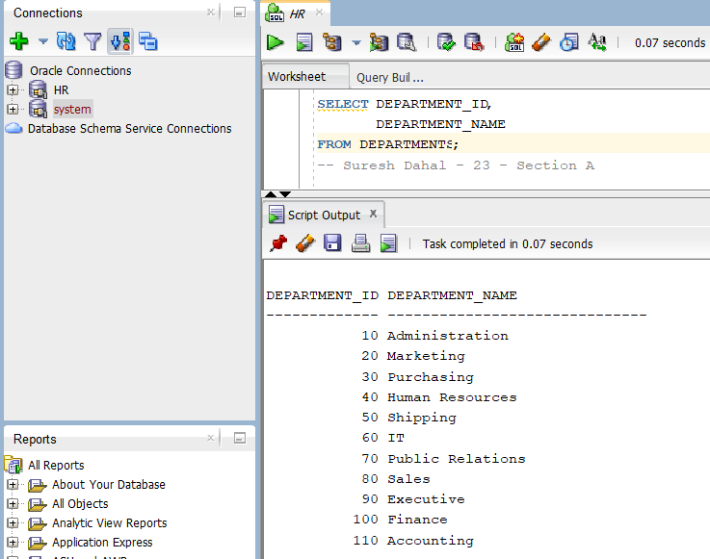

- USER MANAGEMENT WITH GRANT AND REVOKE PRIVILEGES.
THEORY:
User Management in Oracle
User management in Oracle is the process of creating, modifying, and managing database user accounts and their privileges. Oracle provides SQL statements such as CREATE USER, ALTER USER, DROP USER, GRANT, and REVOKE to perform user administration. Proper user management ensures database security by allowing users to access only the resources and operations for which they have been granted permissions.
DBA_USERS View
DBA_USERS is a data dictionary view that contains information about all users in the Oracle database. It provides details such as the username, account status, default tablespace, temporary tablespace, profile, and account creation date. This view is accessible only to users with DBA privileges.

STEPS:
(a) Display Information About Users Using DBA_USERS
Step 1: Display Information About Users
SELECT USERNAME,
ACCOUNT_STATUS,
DEFAULT_TABLESPACE
FROM DBA_USERS;
b) Create a User
Step 4: Create User user_suresh
CREATE USER user_suresh
IDENTIFIED BY pass123;
(c) Grant Privileges to the User
Step 5: Grant System Privileges
GRANT CREATE SESSION,
CREATE TABLE
TO user_suresh;
(d) Create a Table After Logging in as user_suresh
Step 6: Connect as user_suresh
CONNECT user_suresh/pass123@ORCLPDB;
Step 7: Create a Table
CREATE TABLE student (
id NUMBER PRIMARY KEY,
name VARCHAR2(50),
address VARCHAR2(100)
);
(e) Create Another User with Tablespace Clause
Step 8: Create User suresh_dahal
CREATE USER suresh_dahal
IDENTIFIED BY pass123
DEFAULT TABLESPACE USERS
TEMPORARY TABLESPACE TEMP;
(f) Create Another User of Your Choice
Step 10: Create User
CREATE USER test_user
IDENTIFIED BY pass123;
(g) Grant Privileges to the User Created in (f)
Step 11: Grant Privileges
GRANT CREATE SESSION,
CREATE TABLE
TO test_user;
(h) Change the Password of user_suresh
Step 12: Change Password
ALTER USER user_suresh
IDENTIFIED BY pass345;
(i) Enable Password Expiration for suresh_dahal
Step 13: Expire Password
ALTER USER suresh_dahal
PASSWORD EXPIRE;
(j) Grant Object Privileges on the Table
Step 14: Connect as user_suresh
CONNECT user_suresh/pass345@ORCLPDB;
Step 15: Grant Object Privileges
GRANT SELECT,
INSERT,
UPDATE,
DELETE
ON student
TO suresh_dahal;
(k) Insert, Update and Select Records by Logging in as suresh_dahal
Step 16: Connect as suresh_dahal
CONNECT suresh_dahal/pass123@ORCLPDB;

Step 17: Insert Two Records
INSERT INTO user_suresh.student
VALUES (1, 'Ram', 'Kathmandu');

INSERT INTO user_suresh.student
VALUES (2, 'Hari', 'Pokhara');

Step 18: Update the Second Record
UPDATE user_suresh.student
SET address = 'Lalitpur'
WHERE id = 2;

Step 19: Display All Records
SELECT *
FROM user_suresh.student;
(l) Revoke DELETE Privilege
Step 20: Connect as user_suresh
CONNECT user_suresh/pass345@ORCLPDB;

Step 21: Revoke DELETE Privilege
REVOKE DELETE
ON student
FROM suresh_dahal;

(m) Remove the User Created in (f)
Step 22: Connect as SYSDBA
CONNECT / AS SYSDBA;

Step 23: Drop the User
DROP USER test_user CASCADE;

OUTPUT:
(a) Display Information About Users Using DBA_USERS
Step 1: Display Information About Users
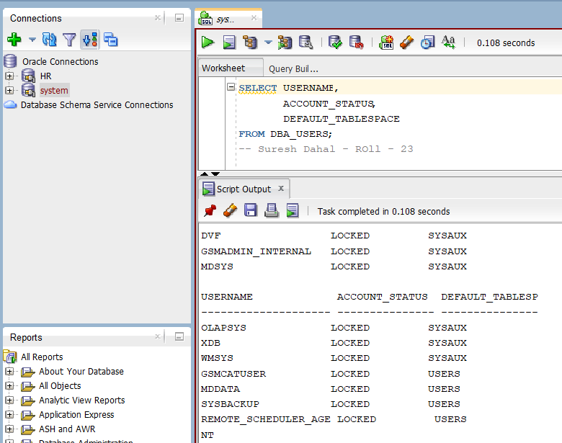
b) Create a User
Step 4: Create User user_suresh
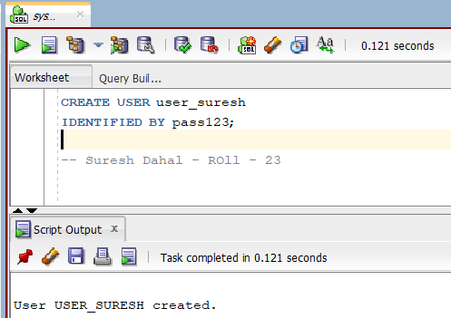
(c) Grant Privileges to the User
Step 5: Grant System Privileges
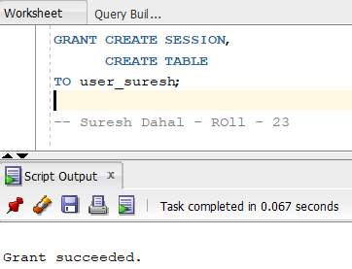
(d) Create a Table After Logging in as user_suresh
Step 6: Connect as user_suresh
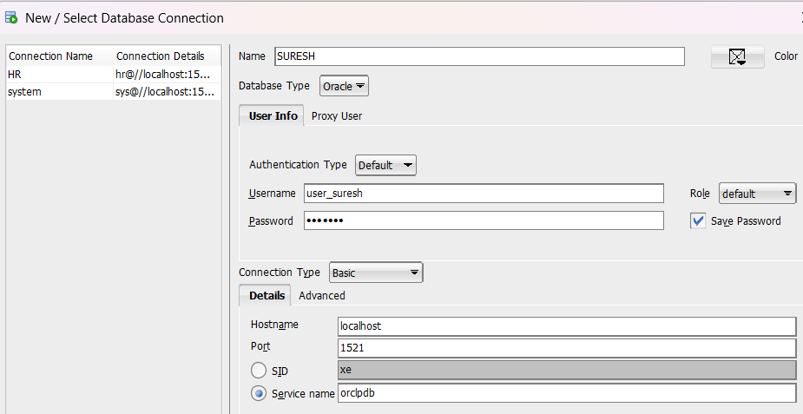

Step 7: Create a Table
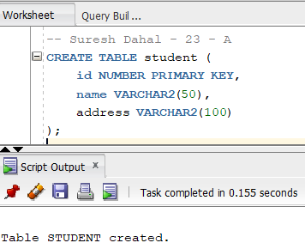
(e) Create Another User with Tablespace Clause
Step 8: Create User suresh_dahal
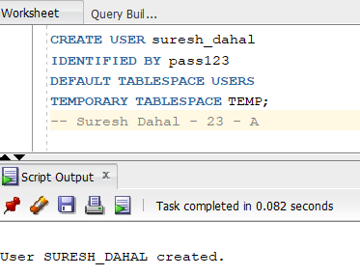
(f) Create Another User of Your Choice
Step 10: Create User
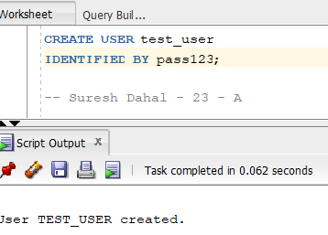
(g) Grant Privileges to the User Created in (f)
Step 11: Grant Privileges
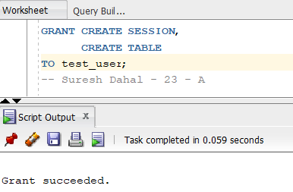
(h) Change the Password of user_suresh
Step 12: Change Password
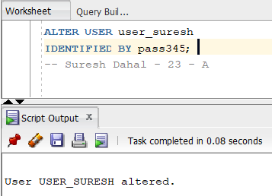
(i) Enable Password Expiration for suresh_dahal
Step 13: Expire Password
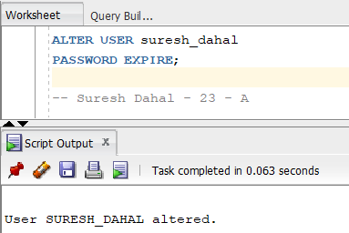
(j) Grant Object Privileges on the Table
Step 14: Connect as user_suresh
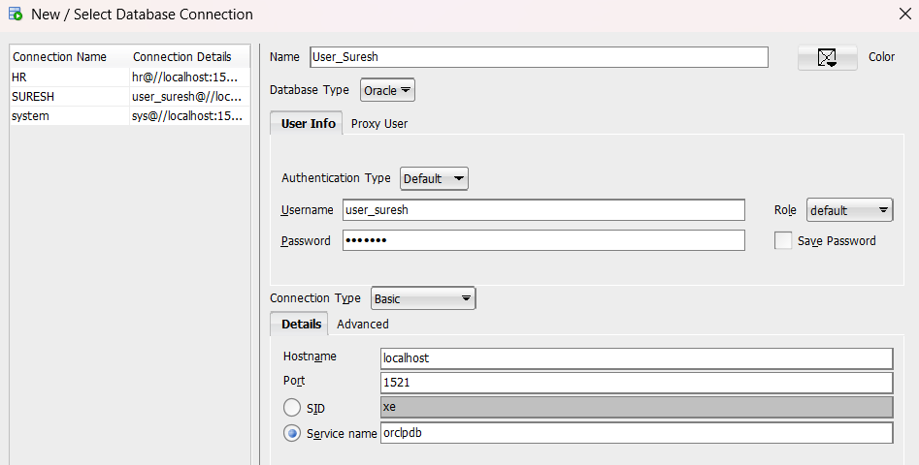Step 15: Grant Object Privileges
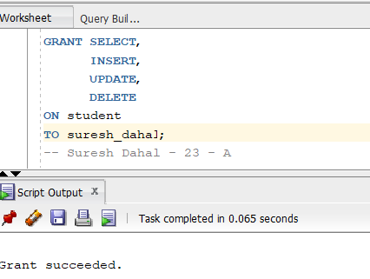
(k) Insert, Update and Select Records by Logging in as suresh_dahal
Step 16: Connect as suresh_dahal
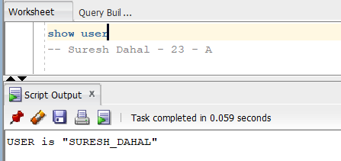
Step 17: Insert Two Records
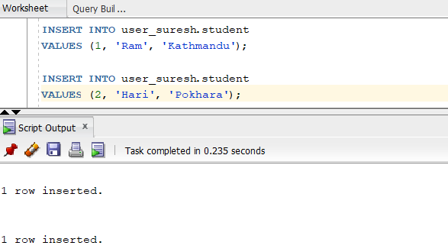
Step 18: Update the Second Record
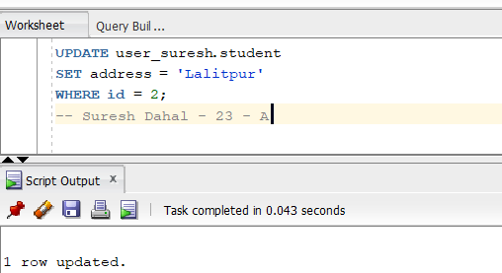
Step 19: Display All Records
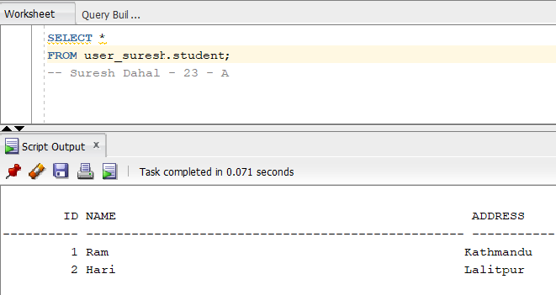
(l) Revoke DELETE Privilege
Step 20: Connect as user_suresh
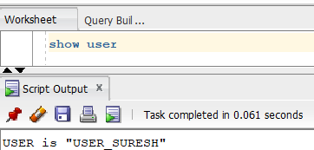
Step 21: Revoke DELETE Privilege
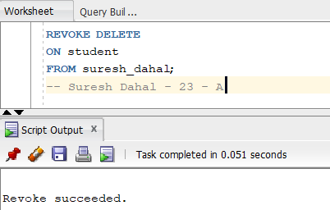
(m) Remove the User Created in (f)
Step 22: Connect as SYSDBA
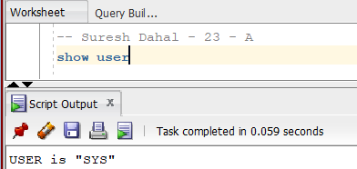
Step 23: Drop the User
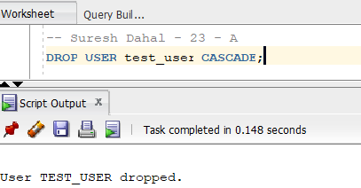

- WORKING WITH ROLES AND PRIVILEGES.
THEORY:
A role is a collection of privileges that can be granted to one or more users. Roles simplify privilege management by allowing administrators to assign or revoke multiple privileges at once. Oracle supports system privileges such as CREATE TABLE and object privileges such as SELECT, INSERT, and UPDATE on specific database objects. Roles are managed using SQL statements like CREATE ROLE, GRANT, REVOKE, and DROP ROLE.
STEPS:
- Create a Role Named role_by_yourName
Step 1: Create the Role
CREATE ROLE role_by_suresh;
(b) Grant System and Object Privileges to the Role
Step 2: Grant a System Privilege
GRANT CREATE TABLE TO role_by_suresh;
Step 3: Connect as the Owner of the Table
CONNECT user_suresh/password@ORCLPDB;
Step 5: Grant Object Privileges
GRANT SELECT,
INSERT,
UPDATE
ON student
TO role_by_suresh;

(c) Assign the Role to the User Created in Lab 8(b)
Step 6: Connect as SYSTEM
CONNECT system/password@ORCLPDB;

Step 7: Grant the Role
GRANT role_by_suresh
TO user_suresh;

(d) View Roles Granted to a User
Step 8: Display Roles Granted to the User
SELECT GRANTEE,
GRANTED_ROLE
FROM DBA_ROLE_PRIVS
WHERE GRANTEE = 'USER_SURESH';

(e) Display Privileges Granted to the Role
Step 9: Display System Privileges
SELECT ROLE,
PRIVILEGE
FROM ROLE_SYS_PRIVS
WHERE ROLE = 'ROLE_BY_SURESH';

Step 10: Display Object Privileges
SELECT GRANTEE,
TABLE_NAME,
PRIVILEGE
FROM DBA_TAB_PRIVS
WHERE GRANTEE = 'ROLE_BY_SURESH';

(f) Create Another Role
Step 11: Create a New Role
CREATE ROLE manager_role;

Step 12: Grant Privileges
GRANT CREATE SESSION,
CREATE VIEW
TO manager_role;
(g) Modify the Role Created in (f)
Step 13: Grant an Additional Privilege
GRANT CREATE SEQUENCE
TO manager_role;

Step 14: Revoke a Privilege
REVOKE CREATE VIEW
FROM manager_role;

(h) Drop the Role Created in (f)
Step 15: Drop the Role
DROP ROLE manager_role;

OUTPUT:
    - Create a Role Named role_by_yourName
Step 1: Create the Role
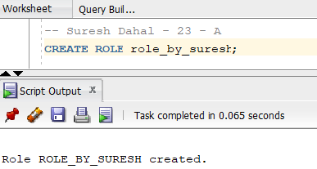
    - Grant System and Object Privileges to the Role
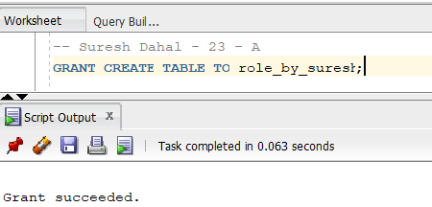
Step 2: Grant a System Privilege
Step 3: Connect as the Owner of the Table
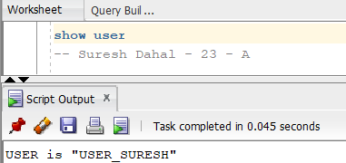
Step 5: Grant Object Privileges
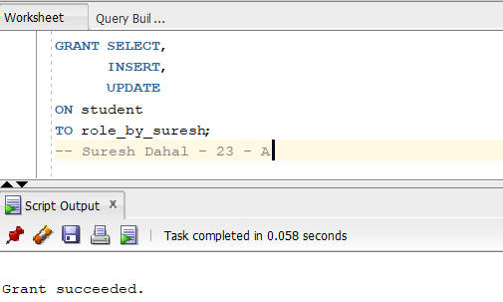
(c) Assign the Role to the User Created in Lab 8(b)
Step 6: Connect as SYSTEM
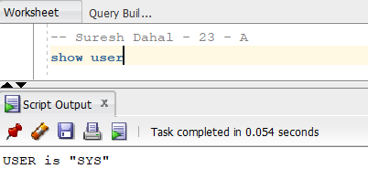
Step 7: Grant the Role
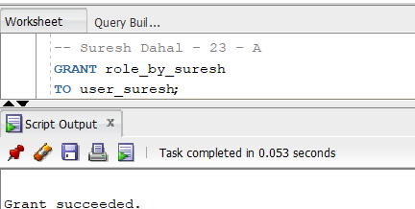
(d) View Roles Granted to a User
Step 8: Display Roles Granted to the User
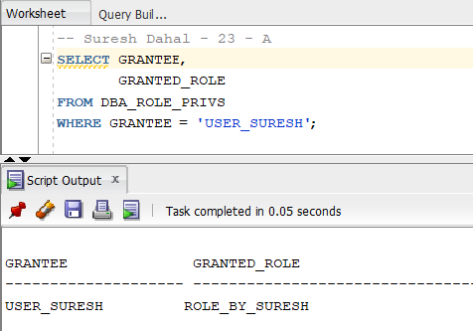
(e) Display Privileges Granted to the Role
Step 9: Display System Privileges
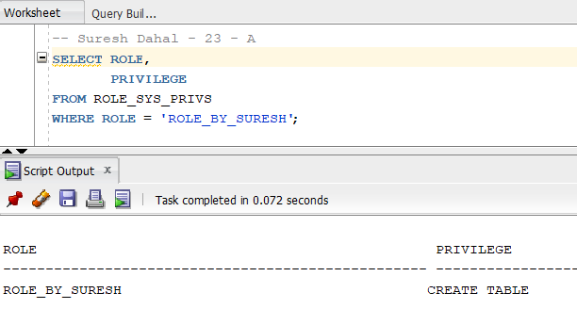
Step 10: Display Object Privileges
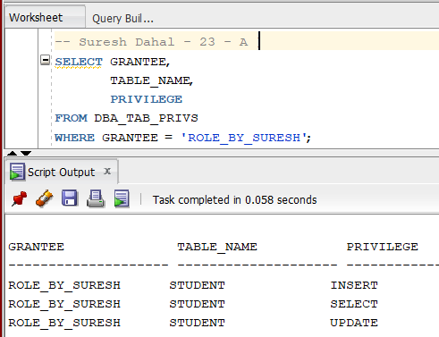
(f) Create Another Role
Step 11: Create a New Role
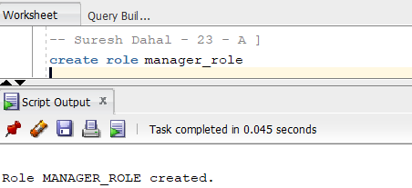
Step 12: Grant Privileges
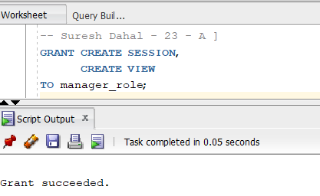
(g) Modify the Role Created in (f)
Step 13: Grant an Additional Privilege
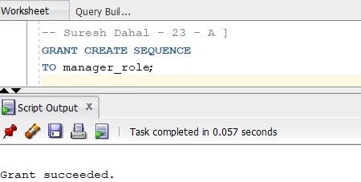
Step 14: Revoke a Privilege
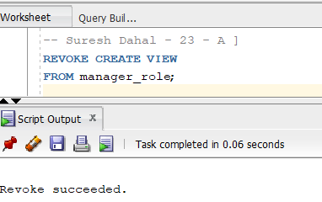
(h) Drop the Role Created in (f)
Step 15: Drop the Role
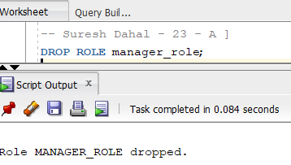

- WORKING WITH PROFILES.
THEORY:
A profile is a collection of resource limits and password management policies assigned to database users. Profiles help database administrators control resource usage and enforce password security. A profile can be assigned to one or more users and managed using the CREATE PROFILE, ALTER PROFILE, DROP PROFILE, and ALTER USER statements.
STEPS:
(a) Create a Profile Named profile_by_yourName
Step 1: Connect as SYSTEM
Connect as system in Oracle SQL Developer.
Step 2: Create the Profile
CREATE PROFILE profile_by_suresh
LIMIT
SESSIONS_PER_USER 2
CPU_PER_SESSION 10000
CONNECT_TIME 60
IDLE_TIME 15
FAILED_LOGIN_ATTEMPTS 3
PASSWORD_LIFE_TIME 30
PASSWORD_GRACE_TIME 7;

(b) Assign the Profile to the User Created in Practical 8(b)
Step 3: Assign the Profile
ALTER USER user_suresh
PROFILE profile_by_suresh;

(c) View Profile Information
Step 4: Display All Profiles
SELECT PROFILE,
RESOURCE_NAME,
LIMIT
FROM DBA_PROFILES
ORDER BY PROFILE;

Step 5: Display Information About the Created Profile
SELECT PROFILE,
RESOURCE_NAME,
LIMIT
FROM DBA_PROFILES
WHERE PROFILE = 'PROFILE_BY_SURESH';

(d) Create Another Profile
Step 6: Create a New Profile
CREATE PROFILE test_profile
LIMIT
SESSIONS_PER_USER 1
IDLE_TIME 10
PASSWORD_LIFE_TIME 20;

(e) Modify the Profile and Display Updated Information
Step 7: Modify the Profile
ALTER PROFILE test_profile
LIMIT
IDLE_TIME 20
PASSWORD_LIFE_TIME 45;

Step 8: Display the Updated Profile
SELECT PROFILE,
RESOURCE_NAME,
LIMIT
FROM DBA_PROFILES
WHERE PROFILE = 'TEST_PROFILE';

(f) Drop the Profile and Display Updated Information
Step 9: Drop the Profile
DROP PROFILE test_profile;
If the profile is assigned to any user, use:
DROP PROFILE test_profile CASCADE;

Step 10: Display the Remaining Profiles
SELECT PROFILE,
RESOURCE_NAME,
LIMIT
FROM DBA_PROFILES
ORDER BY PROFILE;

OUTPUT:
(a) Create a Profile Named profile_by_yourName
Step 1: Connect as SYSTEM
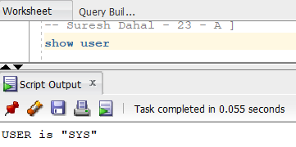
Step 2: Create the Profile
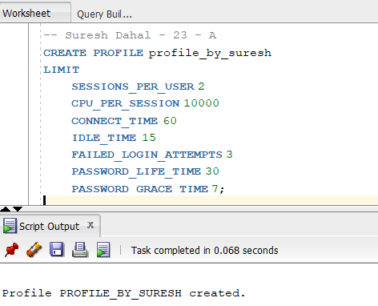
(b) Assign the Profile to the User Created in Practical 8(b)
Step 3: Assign the Profile
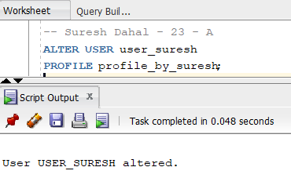
(c) View Profile Information
Step 4: Display All Profiles
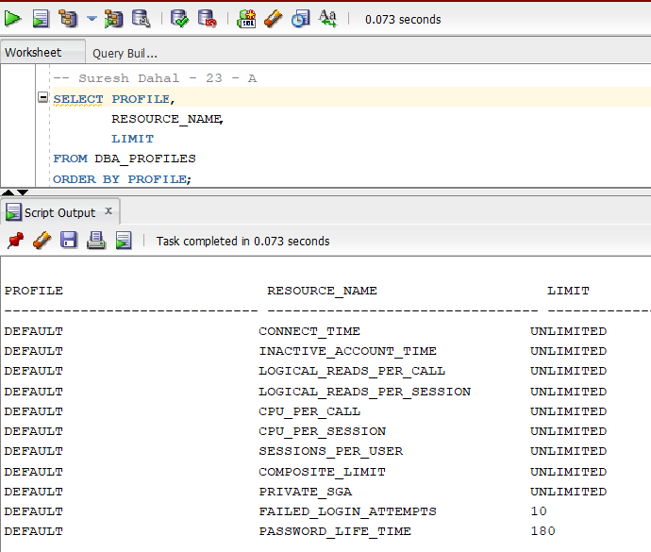
Step 5: Display Information About the Created Profile
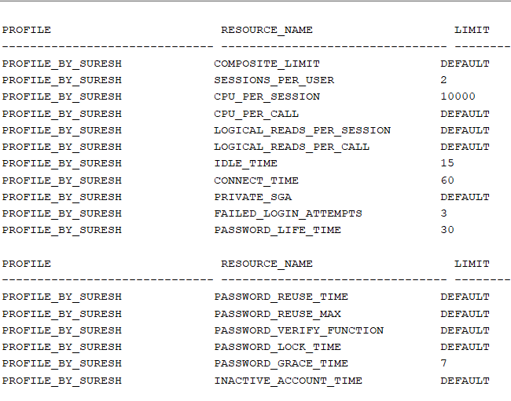
(d) Create Another Profile
Step 6: Create a New Profile
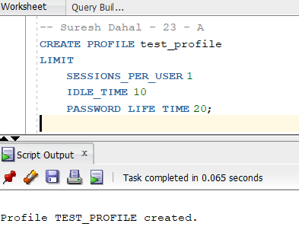
(e) Modify the Profile and Display Updated Information
Step 7: Modify the Profile
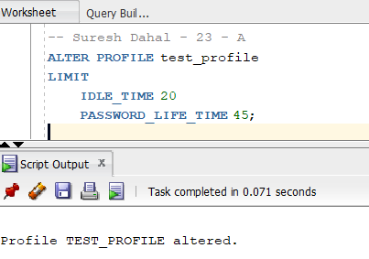
Step 8: Display the Updated Profile
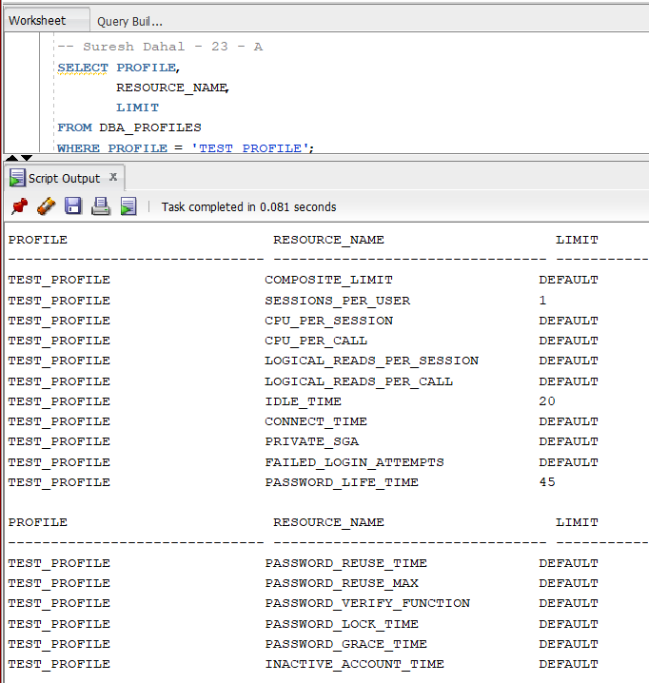
(f) Drop the Profile and Display Updated Information
Step 9: Drop the Profile
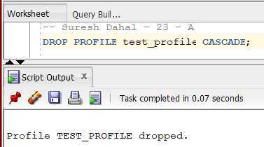
Step 10: Display the Remaining Profiles
